AyurSense: An Intelligent Ayurvedic Recommendation System
Project Report
Submitted in Partial Fulfillment of the Requirements for the Degree of
BACHELOR OF TECHNOLOGY
in
COMPUTER SCIENCE & ENGINEERING
By
Manya Thapliyal
(2200950100048)

UNDER THE GUIDANCE OF
Mrs. Roovi Goswami

DEPARTMENT OF COMPUTER SCIENCE & ENGINEERING
MGM’s College of Engineering & Technology, Noida
May 2026

TABLE OF CONTENTS
Page No.

CERTIFICATE................................................................................................ I
DECLARATION.............................................................................................. II
ACKNOWLEDGEMENT ............................................................................... III
ABSTRACT..................................................................................................... IV
LIST OF FIGURES ........................................................................................ V
LIST OF ABBREVITAIONS ......................................................................... VI

CHAPTER 1 (INTRODUCTION)
1.1 Literature Review................................................................................. 1
1.2 Problem Definition............................................................................... 2
1.3 Brief Introduction of the Project .......................................................... 2-3
1.4 Objectives of the Project ...................................................................... 3-4
1.5 Scope of the Project ............................................................................. 4
1.6 Proposed Modules ................................................................................ 5
1.7 Hardware and Software Requirements ................................................ 5-6
1.8 Ayurvedic Dosha Theory (Vata, Pitta, Kapha) ..................................... 6-9

CHAPTER 2 (SYSTEM ANALYSIS AND SPECIFICATION)
2.1 Functional Model ................................................................................. 10
2.2 Data Model........................................................................................... 11-17
2.2.1. Types of Data Models Use
2.3 Process Flow Model ............................................................................. 17-18
2.4 Behavioral Model................................................................................. 18-19
2.5 System Design and Feasibility Analysis .............................................. 19-21

CHAPTER 3 (MODULE IMPLEMENTATION AND SYSTEM INTEGRATION)
3.1 Introduction ......................................................................................... 22
3.2 User Interface Module ......................................................................... 22-23
3.3 Quiz Module ........................................................................................ 23
3.4 Dosha Detection Module ..................................................................... 24
3.5 Recommendation Module ................................................................... 24-25
3.6 Yoga Recommendation Module ........................................................... 25
3.7 Diet Plan Generation Module .............................................................. 26
3.8 Blog and Content Module .................................................................... 26-27
3.9 System Integration ............................................................................... 27
3.10 Challenges Faced During Implementation......................................... 27-28

CHAPTER 4 (TESTING AND EVALUATION)
4.1 Introduction .......................................................................................... 29
4.2 Testing Objectives ............................................................................. 29-30
4.3 Types of Testing Performed ................................................................. 30-31
4.3.1. Unit Testing
4.3.2. Integration Testing
4.3.3. System Testing
4.3.4. User Acceptance Testing
4.4 Test Case Design ................................................................................. 31-32
4.5 Performance Evaluation .................................................................... 32-33
4.6 ResultAnalysis..................................................................................... 34
4.7 Limitations Identified During Testing .................................................. 34
4.8 Improvements After Testing................................................................. 35
4.9 Conclusion ........................................................................................... 35

CHAPTER 5 (TASK ANALYSIS AND SCHEDULE OF ACTIVITIES)
5.1 Introduction .......................................................................................... 36
5.2 Task Identification ............................................................................... 36-37
5.3 Task Decomposition ............................................................................. 37
5.4 Activity Scheduling ............................................................................. 38
5.5 Gantt Chart Representation ................................................................. 38-39
5.6 Resource Allocation ............................................................................. 39
5.7 Time Management ............................................................................... 40
5.8 Risk Management ................................................................................40-41
5.9 Conclusion ..............................................................................................41

CHAPTER 6 (PROJECT MANAGEMENT)
6.1 Introduction .......................................................................................... 42
6.2 Project Planning ...................................................................................42-43
6.3 Project Scheduling ............................................................................... 43
6.4 Resource Management .........................................................................43-44
6.5 Risk Management ................................................................................ 44
6.6 Team Management ............................................................................... 45
6.7 Quality Management ............................................................................ 45
6.8 Documentation Management ............................................................... 46
6.9 Conclusion ........................................................................................... 46

CHAPTER 7 (SYSTEM DESIGN AND ARCHITECTURE)
7.1 Introduction .......................................................................................... 47
7.2 System Architecture Overview ............................................................47-48
7.3 Design Principles ................................................................................. 48
7.4 Data Flow Architecture ........................................................................48-49
7.5 Frontend Design Architecture .............................................................. 49
7.6 Backend Design Architecture .............................................................. 50
7.7 Database and Data Handling Design ...................................................50-51
7.8 System Workflow ................................................................................. 51
7.9 Advantages of the Architecture ............................................................ 52
7.10 Conclusion…………………………………………………………... 52

CHAPTER 8 (SYSTEM INTERFACE AND OUTPUT SCREENSHOTS)
8.1 Introduction .......................................................................................... 53
8.2 Home Page Interface ............................................................................53-54
8.3 About Section....................................................................................... 55
8.4 User Registration Page .........................................................................55-56
8.5 User Login Page ...................................................................................56-57
8.6 Personalized Quiz Interface ................................................................. 57-58
8.7 Dosha Result Page ............................................................................... 59
8.8 Ayurvedic Remedies Section ............................................................... 60
8.9 Yoga and Exercises Section ................................................................. 61
8.10 Diet Suggestions Section……………………………………………. 62
8.11 Blog Section…………………………………………………………. 63

8.12 Footer Section……………………………………………………….63-64

8.13 FAQ section ....................................................................................... 64
8.14 Testimonials Section ............................................................................65

CHAPTER 9 (RESULTS, CONCLUSION AND FUTURE SCOPE)
9.1 Introduction Results of the System ...................................................... 66
9.2 Results of System ……………………………………………………66-67
9.3 Analysis of Results .............................................................................. 67
9.4 Benefits of the System ........................................................................67-68
9.5 Limitations of the System .................................................................... 68
9.6 Future Scope ........................................................................................ 69
9.7 Practical Applications ........................................................................69-70
9.8 Overall Conclusion .............................................................................. 70
PLAGIARISM OF REPORT……………………………………………. 71
RESEARCH PAPER-1………………………………………………… 72-78
CERTIFICATE OF RESEARCH PAPER-1…………………………….. 79
RESEARCH PAPER-2…………………………………………………. 80-86
CERTIFICATE OF RESEARCH PAPER-2…………………………… 87
REFERENCES ......................................................................................... 88-89

CERTIFICATE

This is to certify that the Project Report entitled “AYURSENSE: An Intelligent Ayurvedic Recommendation System” which is submitted by Manya Thapliyal
in partial fulfilment of the requirement for the award of the degree of Bachelor of Technology (B. Tech.) in the Department of Computer Science and Engineering of MGM’s College of Engineering and Technology, affiliated to Dr. A.P.J. Abdul Kalam Technical University (AKTU), Lucknow, is a record of the candidate’s own work carried out by her under my supervision.
The matter embodied in this report is original and has not been submitted for the award of any other degree.

Project Guide

(Signature)
Name: Mrs. Roovi Goswami
Designation: Assistant Professor

Date: _________________________
Place: Noida

DECLARATION

I hereby declare that the Project Report entitled “AYURSENSE: An Intelligent Ayurvedic Recommendation System” is my own work and that, to the best of our knowledge and belief, it contains no material previously published or written by another person nor material which to a substantial extent has been accepted for the award of any other degree or diploma of the university or any other institute of higher learning, except where due acknowledgment has been made in the text.
I further declare that this project report has been submitted in partial fulfillment of the requirement for the award of the degree of Bachelor of Technology (B. Tech.) in Computer Science and Engineering.

Submitted By:
Name: Manya Thapliyal
Roll No.: 2200950100048
Sign.:

Date: __________________________
Place: __________________________

ACKNOWLEDGEMENT

It gives me a great sense of pleasure to present the report of the B. Tech Project undertaken during B. Tech. Final Year. I owe special debt of gratitude to
Mrs. Roovi Goswami, Department of Computer Science & Engineering, MGM’s College of Engineering and Technology, Noida for her constant support and guidance throughout the course of my work. Her sincerity, thoroughness and perseverance have been a constant source of inspiration for me. It is only her cognizant efforts that my endeavors have seen light of the day.
I also take the opportunity to acknowledge the contribution of Mrs. Karamjeet Kaur Head, Department of Computer Science & Engineering, MGM’s College of Engineering and Technology, Noida for her full support and assistance during the development of the project.
I also do not like to miss the opportunity to acknowledge the contribution of all faculty members of the department for their kind assistance and cooperation during the development of my project.

Signature:
Name: Manya Thapliyal
Roll No.: 2200950100048

ABSTRACT

The growing need for personalized healthcare has led to the use of new technology in traditional medical systems. AYURSENSE, an intelligent Ayurvedic recommendation system, functions as a web-based platform designed to deliver personalized health guidance rooted in Ayurvedic principles. Its primary objective is to assess a user's constitutional body type, or Dosha, and subsequently generate tailored advice concerning dietary regimens, lifestyle adjustments, herbal formulations, and suitable yoga practices.
Data collection occurs through a series of structured questionnaires that probe an individual's lifestyle habits, daily routines, psychological tendencies, and physical attributes. Upon completion, a proprietary algorithm evaluates the responses, assigning scores to determine the predominant Dosha among the three primary types—Vata, Pitta, or Kapha. This diagnostic process enables the system to formulate individualized health insights.
A comprehensive Ayurvedic dataset is systematically integrated within the platform to facilitate optimal, Dosha-specific recommendations. Each personalized output encompasses four distinct informational categories: dietary guidelines detailing beneficial and adverse foods; daily routines, known as Dinacharya; seasonal regimens, or Ritucharya; and a selection of yoga asanas aimed at restoring balance to the identified Dosha. Furthermore, the system incorporates a preventive healthcare dimension by offering long-term maintenance strategies to support sustained well-being.
The platform's backend will employ the Flask framework, which supports the efficient handling and processing of user inputs. A frontend application developed with HTML, CSS, JavaScript, and Bootstrap will deliver a responsive and user-friendly interface. This architecture ensures seamless communication between client and server components, facilitating immediate responses with minimal latency.
The AYURSENSE website includes an educational section designed to instruct users on fundamental Ayurvedic principles, clarify the importance of Dosha balance, and present examples of natural healing techniques that can support overall wellness. This educational content equips users not only with specific recommendations, but also with the knowledge required to make informed decisions regarding their health and well-being.
The results show that the system works well to make personalized and relevant recommendations, which makes it a useful tool for promoting holistic and preventive healthcare. It connects ancient Ayurvedic knowledge with modern digital technology, showing how smart systems can make traditional healthcare practices easier to get to. The project also shows how future improvements like adding machine learning, tracking health in real time, and making the app available on mobile devices could make it more accurate and interesting for users.

List Of Figures
Sr.  No. | Figure Number | Figure Name | Page  Number
1 | Figure 1.1 | Ayurvedic Dosha Theory Vata | 7
2 | Figure 1.2 | Ayurvedic Dosha Theory Pitta | 8
3 | Figure 1.3 | Ayurvedic Dosha Theory Kapha | 9
4 | Figure 2.1 | Entity Relationship ER Diagram | 13
5 | Figure 2.2 | Class Diagram | 15
6 | Figure 2.3 | Data Flow Diagram DFD Level 0 | 16
7 | Figure 2.4 | Data Flow Diagram DFD Level 1 | 17
8 | Figure 4.1 | Receiver Operating Characteristic ROC Curve | 33
9 | Figure 8.1 | Home Page Carousel Images | 54
10 | Figure 8.2 | Home Page Interface Discover Your Wellness Journey | 54
11 | Figure 8.3 | About Section | 55
12 | Figure 8.4 | User Registration Page | 56
13 | Figure 8.5 | User Login Page | 57
14 | Figure 8.6 | Personalized Quiz Interface | 58
15 | Figure 8.7 | Dosha Result Page | 59
16 | Figure 8.8 | Ayurvedic Remedies Section | 60
17 | Figure 8.9 | Yoga and Exercises Section | 61
18 | Figure 8.10 | Diet Suggestions Section | 62
19 | Figure 8.11 | Blog Section | 63
20 | Figure 8.12 | Footer Section | 64
21 | Figure 8.13 | FAQ Section | 64
22 | Figure 8.14 | Testimonials Section | 65

LIST OF ABBREVIATIONS

Abbreviation | Full Form
HTML | Hypertext Markup Language
CSS | Cascading Style Sheets
JS | JavaScript
UI | User Interface
FAQ | Frequently Asked Questions
ROC | Receiver Operating Characteristic
TPR | True Positive Rate
FPR | False Positive Rate
JSON | JavaScript Object Notation
HTTP | Hypertext Transfer Protocol
SQL | Structured Query Language

CHAPTER 1

INTRODUCTION

1.1 Literature Review
Originating thousands of years ago in India, Ayurveda is one of the oldest comprehensive medical systems. The goal of using plant-based methods, like modifying what you eat, how you live, and using herbs, is to find a balance in your body, mind, and environment. In the last few years there is growing interest in how to combine traditional systems of medicine such as Ayurveda with new technology, and the rise of iPads, computers, etc., has facilitated this collaboration.
Many different websites and applications have been made available to provide Ayurvedic information online. However, they all lack the ability to provide interactive information to cater to individual requirements. In other words, such websites are just like any ordinary website where information can be found on blogs and articles, but the information provided is only generic and does not cater to individual body types and health conditions.
Furthermore, health-related monitoring systems based on algorithms have come to form the foundation of contemporary health systems. While such techniques are effective in monitoring calorie intake or exercising, the factor of Dosha, which forms an integral part of Ayurvedic philosophy, does not come into play here, making the recommendations ineffective.
Despite efforts put in place towards building intelligent healthcare systems, there exists an evident negligence that occurs in regard to the previous knowledge-based systems in favour of the current state-of-the-art medical science. A gap therefore exists between previous knowledge and the application of current technology. There is an immediate need for a system through which one would provide health care solutions based on Ayurveda.
In order to overcome these issues, AYURSENSE makes use of an intelligent Ayurvedic recommendation system. Not only will this system offer information, but it will also assess users' inputs and make recommendations based on Ayurvedic concepts.

1.2 Problem Definition
People are increasingly dealing with health-related problems like stress, poor digestion, inactivity, and inconsistent sleep patterns in today's fast-paced, tech-driven lifestyle. Most people are unaware of their body types and the medicines they need for themselves because Ayurveda treatment works well, and it uses natural techniques to resolve these issues.
One of the issues is the lack of individualized recommendations for Ayurveda. Traditional consultations for Ayurveda might not always be readily available and require specialized knowledge. On the other hand, the online resources tend to offer extensive theoretical data without any real-world solutions to the issue.
Yet another problem that should be highlighted pertains to the absence of technology that will help process the user inputs and suggest the right activities. Most apps that exist nowadays are very simple and cannot account for individual differences between users, their lifestyle, behavior patterns, and level of health.
The key problems can be summarized as follows:
- Lack of awareness about individual Dosha (body constitution)
- Absence of personalized health recommendations
- Static and non-interactive Ayurvedic platforms
- Difficulty in selecting appropriate diet and yoga practices
- Limited integration of traditional knowledge with modern technology
These challenges highlight the need for an intelligent system that can simplify
Ayurvedic concepts and make them accessible, interactive, and personalized for users.

1.3 Brief Introduction of the Project
An sophisticated web-based Ayurvedic recommendation system called AYURSENSE was created to offer individualized health solutions based on the unique qualities of each user. The system makes use of the integration of current web-based technology and Ayurveda-based ideas in order to provide a platform that is interactive and convenient for the user.
The key component of the system is the design of a questionnaire that enables the collection of information related to the user’s activities, behavior, and health concerns. It helps determine the Dosha of the user, which is a significant aspect of Ayurveda.
This approach results in the generation of personalized advice for each individual in the form of diet plans, yoga postures, and Ayurvedic medicines based on Dosha analysis. The advice is provided from an organized database consisting of authentic knowledge about Ayurveda. The backend process ensures that the output generated is relevant and personalized to the individual's requirements.
Through its education services provided through blogs and articles, the system enables users to get additional knowledge regarding Ayurveda. Through the inclusion of various modules, the flawless functioning and full wellness package offered by the system are ensured.
The main features of the system include:
- Quiz-based user assessment
- Dosha identification (Vata, Pitta, Kapha)
- Personalized yoga and exercise suggestions
- AI-based diet plan generation
- Ayurvedic remedies and wellness tips
- Informational blogs and content
Overall, AYURSENSE serves as a bridge between traditional healthcare practices and modern intelligent systems, making Ayurvedic guidance more accessible and practical for users.

1.4 Objectives of the Project
The primary objective of this project is to develop an intelligent system that provides personalized Ayurvedic recommendations based on user input. The system aims to promote natural and holistic health practices by combining traditional knowledge with modern technology.
The specific objectives of the project include:
- To design and develop a web-based Ayurvedic recommendation system
- To identify user Dosha using a quiz-based evaluation method
- To provide personalized yoga and exercise suggestions
- To generate customized diet plans based on user health conditions
- To integrate Ayurvedic knowledge with modern web technologies
- To create a simple and interactive user interface
These objectives ensure that the system not only delivers information but also provides practical and useful health solutions.

1.5 Scope of the Project
The scope of the AYURSENSE project is focused on developing a web-based platform that delivers personalized health recommendations using Ayurvedic principles. The system is designed for individuals who are interested in improving their lifestyle through natural and holistic methods.
The application allows users to understand their body constitution and receive guidance related to diet, exercise, and daily habits. It is accessible through a web browser, making it convenient for users to interact with the system from anywhere.
The project primarily covers:
- User health assessment through quiz
- Dosha-based classification
- Recommendation of remedies, yoga, and diet plans
- Dynamic processing of user input
However, it is important to note that the system is intended for general wellness guidance and should not be considered a replacement for professional medical advice.

1.6 Proposed Modules
The AYURSENSE system is divided into multiple modules, each responsible for a specific functionality. These modules work together to ensure smooth operation and accurate output generation.
The major modules of the system include:
- User Interface Module for interaction
- Quiz Module for data collection
- Dosha Detection Module for classification
- Recommendation Module for suggestions
- Diet Plan Module for nutrition guidance
- Database Module for data storage
Each module is designed to perform its task efficiently while maintaining integration with other components.

1.7 Hardware and Software Requirements
The system is designed to operate on standard hardware and software configurations, making it accessible and cost-effective.
Hardware Requirements:
- Minimum 4 GB RAM
- Basic processor (Intel i3 or above)
- Internet connectivity
Software Requirements:
- Frontend: HTML, CSS, JavaScript, Bootstrap
- Backend: Flask (Python)
- Web Browser: Chrome, Edge
- Operating System: Windows or Linux
- Database: MySQL
- Development tools: MySQL
These requirements ensure that the system can be easily developed, deployed, and used without the need for advanced infrastructure.

1.8 Ayurvedic Dosha Theory (Vata, Pitta, Kapha)
Ayurveda is based on the fundamental concept of Panchmahabhoot (five elements), which include Ether (Akash), Air (Vayu), Fire (Agni), Water (Jal), and Earth (Prithvi). According to Ayurvedic science, these five elements combine to form three primary biological energies known as Doshas — Vata, Pitta, and Kapha.
These Doshas play a vital role in maintaining the physical, mental, and emotional balance of the human body. Every individual has a unique combination of these Doshas, and any imbalance among them can lead to health issues. The AYURSENSE system is based on this concept, where user responses are analyzed to determine their dominant Dosha and provide personalized recommendations.

• Vata Dosha (Air + Ether)
Ether and Air are the constituents of Vata Dosha. This is the dosha responsible for all the bodily functions such as breathing, blood flow, and nervous system impulses.
A person who belongs to the Vata dosha is characterized by qualities like liveliness, creativity, and energy. Nevertheless, complications like anxiety, dehydration, and digestion-related disorders can occur because of the imbalance of Vata.
Vata Dosha Features:
- Vata dosha represents motion.
- The dosha is dry, cold, and light.
- Nervous system is governed by Vata dosha.
- A disharmony can lead to exhaustion and anxiety.

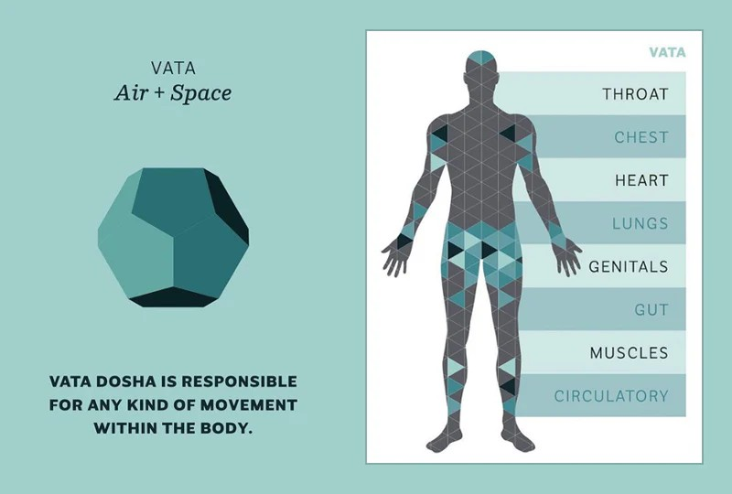

Figure 1.1: Ayurvedic Dosha Theory (Vata)

• Pitta Dosha (Fire + Water)
The Pitta Dosha comes into being due to the combination of the qualities of fire and water. The Pitta Dosha is primarily concerned with the production of energy within the body.
Pitta Dosha types usually are bright, driven, and systematic. Alternatively, an out-of-balance Pitta Dosha will lead to anger, indigestion and inflammation.
The Pitta Dosha has the following features:
- Associated with metabolism
- Aggressive and fiery
- Regulates body temperature and metabolism
- Pitta imbalances can cause irritability and digestive problems.
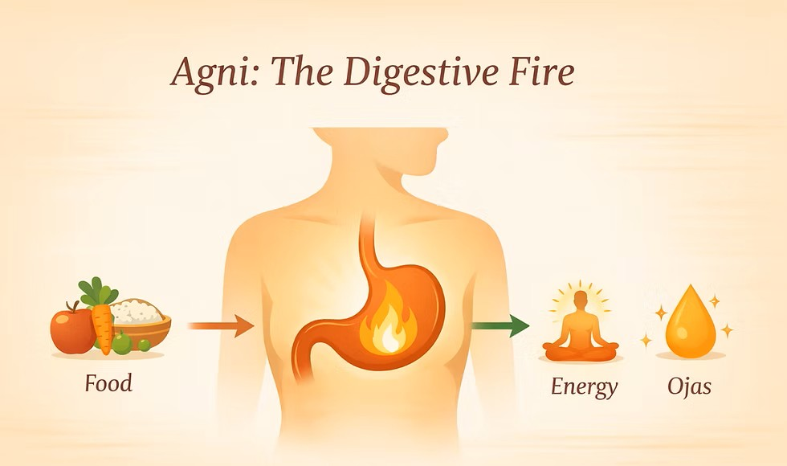

Figure 1.2: Ayurvedic Dosha Theory (Pitta)

• Kapha Dosha (Water + Earth)
The combination of Earth and Water elements gives rise to the Kapha Dosha. The function of this dosha is to provide lubrication and structural strength within the body.
In general, people who are dominated by the Kapha Dosha have characteristics that are peaceful, grounded, and nurturing. However, obesity, lethargy, and sluggish metabolism result from an excess of the Kapha Dosha.
Characteristics of Kapha Dosha:
- Associated with firmness and structure
- Cold, sluggish, and heavy in nature.
- Endows immunity and physical strength
- Makes one lethargic and congested when imbalanced.



Figure 1.1: Ayurvedic Dosha Theory (Kapha)

• Role of Dosha Balance in Health
A balanced body is achieved by maintaining an equilibrium between all the three Doshas in appropriate proportions. The AYURSENCE application uses tests to ascertain which Dosha dominates and suggests appropriate measures, from food intake to Yoga positions and Ayurveda medicines.

CHAPTER 2

SYSTEM ANALYSIS AND SPECIFICATION

2.1 Functional Model
The AYURSENSE system's functional model breaks down the system's overall functionality into more manageable, smaller parts. It serves as an all-encompassing description of how inputs are received and converted into useful outputs. The functional model helps in understanding the key processes involved in the system and their relationship with each other.
The process begins when the user interacts with the website and performs the quiz. The information gathered from the quiz pertain to the lifestyle, personality, and physiology of the individual taking the quiz. After the data are transferred to the back-end part of the application, the information gathered will be processed according to the programming of the system. After the data analysis, the process will yield the scores for the three Doshas, which include Vata, Pitta, and Kapha.
With the highest score from the data analysis result, the Dosha which dominates is determined by the system. Recommendations for each user are made based on the results of the analysis. This includes personalized food regimes, yoga poses, and other ayurveda treatments. Overall, this set of data shall be presented to the user in an organized manner.
The functional approach allows for effective performance in a well-thought-out manner as each of the functions performed helps meet the overall objective, which is to offer customized health solutions.
The main functional components of the system are:
- User input collection through quiz
- Processing of responses using backend logic
- Dosha identification based on scoring mechanism
- Generation of personalized recommendations
This structured approach improves system efficiency and ensures accurate output generation.

2.2 Data Model
The AYURSENSE system's data model outlines the organization, storage, and management of data to guarantee effective processing and precise output production. This is because all the relevant information is organized in an orderly manner, forming the basis of the entire system. Input from the user, consistency in the process of data management, and proper recommendation all depend on the data model.
Data Model in use for the AYURSENCE application is designed to facilitate interactions among several modules that include the suggestions generator module, dosha type identifier module, and quiz processor module. The AYURSENCE application employs a structured database to store different types of data. The ease of retrieving required data from the database is due to the relationship between the data models.
Different datasets are employed within the entire framework, ranging from user dataset, quiz datasets, dosha category datasets, and recommendation datasets, which include different dietary recommendations, yoga poses, remedies, and more. The nature of their structures (JSON) makes it easy for the back-end of the application to manage them.
Responses from all the quizzes that form the inputs to the system are considered part of the user data. Data in the quiz and their correct responses are known as quiz data, where each answer is linked to specific Dosha personalities. Even though recommendation databases contain predefined information on the appropriate treatment methods, yoga postures, and diet, the Dosha database includes properties for Vata, Pitta, and Kapha Doshas.
For accurate output delivery, connections between the data sets are planned out very meticulously. A rating scale method is used to measure user responses that relate to Dosha categories. Using the rating scale technique, suggestions regarding the particular data set are provided based on the dominating Dosha category.
The main data entities involved in the system are:
- User (basic information and answers to the quiz)
- Options and Questions for the Quiz
- Dosha Types: Pitta, Kapha, and Vata
- Data on Wellness and Remedies
- Data on Yoga Exercises
- Information on Diet Plans
A well-organized data model guarantees effective data processing, reduces mistakes, and boosts system performance.

2.2.1 Types of Data Models Used
To represent and understand the structure of the system more effectively, different types of data modeling techniques are used. These models provide both conceptual and logical views of the system and help in visualizing data relationships and workflows.

• Entity-Relationship (E-R) Diagram
The Entity-Relationship (E-R) diagram is used to represent the logical structure of the database. It shows how different entities in the system are related to each other. In the AYURSENSE system, entities such as User, Quiz, Dosha, and Recommendation are interconnected.
The E-R diagram helps in understanding how user responses are linked to Dosha categories and how each Dosha is associated with specific recommendations. It uses entities, attributes, and relationships to represent the data structure.
Key features of E-R Diagram include:
- Representation of entities like User, Quiz, and Dosha
- Attributes defining properties of each entity
- Relationships showing connections between entities
- Clear visualization of data structure
This diagram helps in designing a structured and efficient data model.
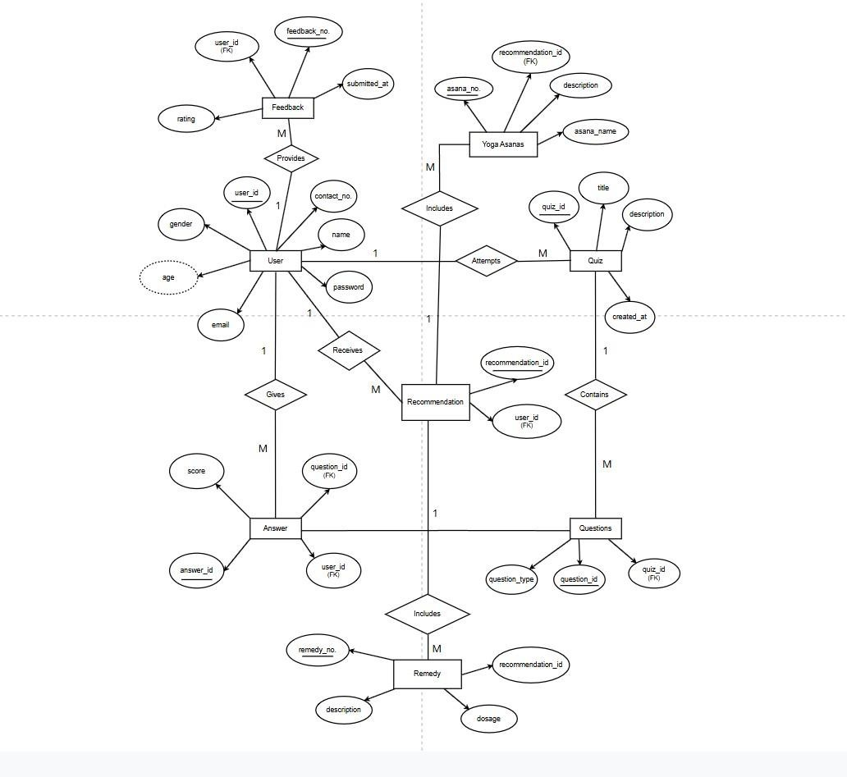
Figure 2.1: Entity-Relationship (E-R) Diagram

• Class Diagram
The system is shown from an object-oriented viewpoint in the class diagram. By displaying classes, their characteristics, and methods together with the connections between various classes, it defines the system's structure.
Classes can stand in for many parts of the AYURSENSE system, including User, Quiz, Dosha Calculator, Recommendation Engine, and Dataset Manager. Every class has unique characteristics and functions that specify how it behaves.
The class diagram aids in comprehending how various system components communicate with one another and how the application processes data.
Key aspects of Class Diagram include:
- System components are represented as classes
- Each class's characteristics and methods
- Relationships such as association and dependency
- The system's object-oriented structure
The system can be implemented in an organized and modular manner with the help of this diagram.
The User class is one of the key classes in the system that will perform activities like quiz-taking, profile management, sign-in, sign-up, and recommendation browsing. Quiz management, solution management, yoga postures, and diet charts will be taken care of by the admin class.
In the Quiz class there are several Answer Options contained within each Question item. The answers submitted by users when taking the quiz are registered in the Quiz Attempt class, and the score received is then examined by the recommendation engine.
The recommendation engine utilizes the inputs given by the users for generating personalized recommendations based on comparison with previous data sets. The recommendations come out of the courses taken such as “Diet Chart”, “Yoga Asana”, and “Remedy”. Blogpost and Feedback are other classes that assist in content management and user interaction.

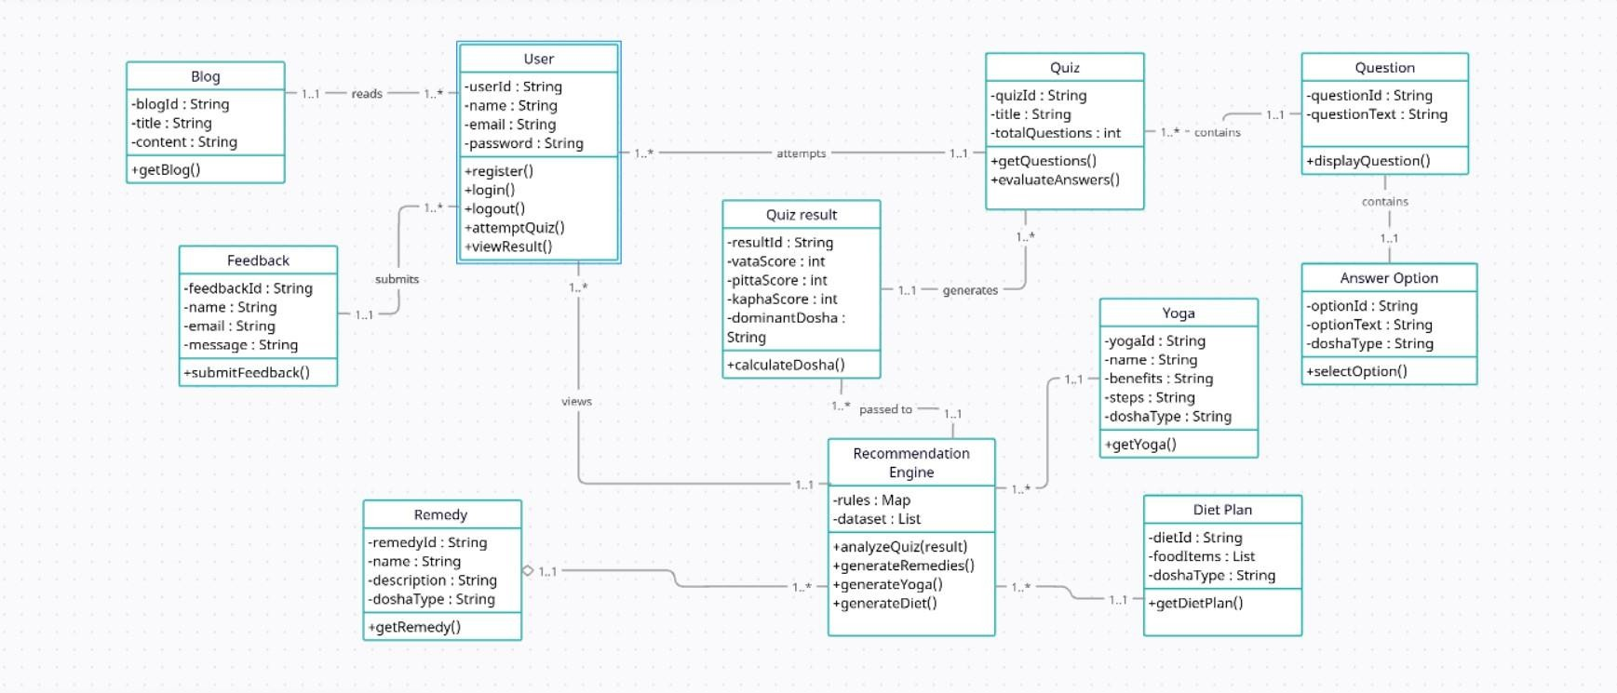
Figure 2.2: Class Diagram

• Data Flow Diagram (DFD)
Data flow through the system is depicted in the Data Flow Diagram (DFD). The information flow between various operations, data stores, and outside entities is its main focus.
The DFD illustrates how user input is gathered via the quiz, processed by the backend, and converted into useful output in the AYURSENSE system. It shows how data moves through the system step-by-step.
The DFD guarantees that the system operates effectively and assists in determining how data is processed at each stage.
Key components of DFD include:
- Processes (data processing activities)
- Data flows (movement of data)
- Data stores (datasets)
- External entities (users)
This diagram provides a clear understanding of system workflow and data processing.

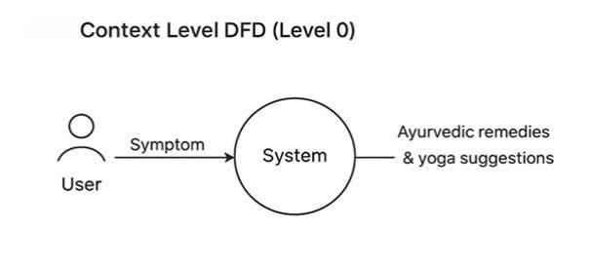
Figure 2.3: Data Flow Diagram (DFD) Level 0
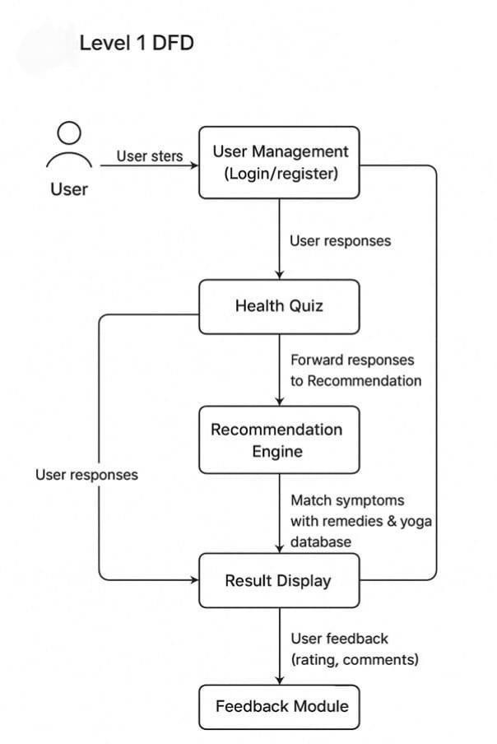
Figure 2.4: Data Flow Diagram (DFD) Level 1

2.3 Process Flow Model
The process flow model explains how various processes interact with one another and how data flows through the system. It makes the workflow easier to comprehend by giving a step-by-step depiction of how the system operates.
When the user inputs data using the quiz interface, the procedure starts. After that, the system's logic is used to process this data on the backend server. After analyzing the answers, the backend determines the Dosha. After identifying the Dosha, the technology pulls pertinent data from the dataset and produces tailored suggestions.
The process flow guarantees that every part of the system functions in unison.
Moreover, this will assist us in pinpointing any areas that may lead to delays in the system and optimizing its efficiency.
This process flow can be summarized in the following steps:
- The input is received through the quiz from the user..
- The next step involves processing the input using the system’s backend.
- The system then computes Dosha and assesses the responses.
- The system generates recommendations based on the Dosha calculation.
This system operates efficiently due to this process flow.

2.4 Behavioral Model
The behavioral model represents how the system behaves under different conditions and how it transitions between different states. The emphasis is put on the system’s dynamic features. It aids in comprehending the response of the system to the user’s activities.
Firstly, the system will be in its idle mode once the user accesses the site. When the user begins the test, the system will shift into the input mode. Upon completion of the answers by the user, the system will enter into the process mode, where all computations will take place. Finally, the system will shift into the output mode.
This state sequence guarantees that the system will function in an orderly fashion. It will also assist in controlling the functioning of the system during various phases of its operation.

The key system states include:
- Initial state (user accesses the system)
- Input state (quiz interaction)
- Processing state (data evaluation)
- Output state (result display)
The transitions between these states ensure smooth execution of the system.

2.5 System Design and Feasibility Analysis
System design and feasibility analysis are important steps in determining whether the proposed system can be successfully implemented. This part of the paper reviews the system under technical, operational, and economic considerations.
The AYURSENSE application is feasible since it incorporates mainstream web technologies such as HTML, CSS, JavaScript, Bootstrap, and Flask. This technology does not need complex infrastructure and is commonly used, as well as easy to implement. Also, this technology is scalable, meaning that new features can be added without undergoing massive changes.
The ease of using the system by the users is what makes up the essence of the feasibility of the system. Because of the nature of the system which is easy to use, even those who do not have much understanding about technology can use the AYURSENSE system.
Economic viability examines the cost involved in establishing and sustaining the system. The system is quite economical since it utilizes the open source system. It is therefore economically viable as there is no need for any hardware or software that could prove to be costly.

The feasibility of the system can be summarized as:
The following are the essential viewpoints that can be considered when assessing the feasibility of the AYURSENSE technology: technological, operational, and economic. These traits make the technology feasible, efficient, and implementable.

• Technical Feasibility
This aspect is usually referred to as the technical feasibility. The available technologies that are used to design and run the system can be regarded as the technical feasibility aspect. Several technological aspects including HTML, CSS, JavaScript, Bootstrap for the front-end, and Flask for Python on the back-end are utilized in the development of the AYURSENSE system.
Determination of Dosha will be attained by using the information provided by the user in a well-organized manner and utilizing the simple scoring method, making it possible to function successfully without requiring sophisticated tools or high computing abilities. The application can efficiently run on ordinary computers that have minimal internet connectivity because it is an online tool.

• Operational Feasibility
The operational feasibility refers to how well the system will perform for the betterment of the end-user. Even persons with minimum knowledge regarding technology can operate the AYURSENSE system due to its user-friendly design, which is achieved through the question-and-answer style of its operation.
The outcome obtained by applying this methodology is easily comprehensible and follows certain procedures like diet plans, yoga recommendations, and calculation of Doshas. In addition, the well-organized approach will facilitate easy interaction of the user with the computer program. Hence, the applicability of the program becomes quite practical in real life, particularly for those who require fundamental guidance in Ayurvedic practices.
Since it makes the system usable, accessible, and productive, the software application becomes practically viable.

• Economic Feasibility
This requirement assesses the cost incurred in designing and supporting the system. As the system relies on many open source software programs including HTML, CSS, JavaScript, Bootstrap, and Flask, none of which requires licensing, it is extremely inexpensive.

The requirements for the hardware in terms of the system are quite minimal since this system can be created through a common computer system. Additionally, the development and maintenance of this system require little money since there will be no costly facilities involved. This is so because it offers an effective solution to the issue while involving very minimal expenses.

CHAPTER 3

MODULE IMPLEMENTATION AND SYSTEM INTEGRATION

3.1 Introduction
This chapter focuses on the implementation of the AYURSENSE system and explains how different modules are developed and integrated to create a complete working application. The implementation phase is one of the most critical stages in system development, as it transforms theoretical concepts and design into a functional system.
The AYURSENSE system is implemented using a combination of frontend and backend technologies. The frontend is developed using HTML, CSS, and JavaScript, which ensures an interactive and user-friendly interface. The backend is developed using Flask, a lightweight Python framework that handles data processing and communication between different modules.
The system follows a modular approach, where each module is responsible for a specific task. These modules are later integrated to ensure smooth operation and efficient data flow. This approach not only improves system organization but also makes it easier to maintain and upgrade the system in the future.

3.2 User Interface Module
The User Interface (UI) module is responsible for enabling interaction between the user and the system. It serves as the visual representation of the application and plays a crucial role in enhancing user experience. The design of the interface focuses on simplicity, clarity, and responsiveness so that users can easily navigate through the system.
The UI includes multiple web pages such as the homepage, about page, quiz page, results page, and blog section. Each page is designed with a specific purpose and provides relevant information to the user. The layout is structured in a way that guides the user step by step, starting from introduction to final recommendations.
The frontend is developed using HTML for structure, CSS/Bootstrap for styling, and JavaScript for adding interactivity. JavaScript is particularly useful for handling user actions, validating inputs, and dynamically updating content without reloading the page.
The main functionalities of the UI module include:
- Displaying web pages and navigation menus
- Collecting user input through forms and quiz
- Presenting results in a structured format
A well-designed interface ensures that users can interact with the system easily and obtain results without confusion.

3.3 Quiz Module
The AYURSENSE system's primary input mechanism is the Quiz Module. The objective is to collect relevant information from the user that will be used to generate recommendations and identify Doshas. This questionnaire comprises several wellformulated questions on lifestyle, habits, physical characteristics, and health problems.
Multiple answers exist for each quiz question, with each answer being associated with specific types of Doshas. With this association, it is possible for the system to evaluate how the users reacted and rate their Doshas. The way this quiz is made ensures that it covers all essential aspects.
The JavaScript code is utilized to capture and hold the responses selected by the user temporarily. Once the quiz session ends, the information is then transmitted to the server for further processing. Prior to submission, the module checks whether the input data is valid and complete.
The key features of the quiz module include:
- Structured set of 15 questions
- Options mapped to Dosha categories
- Real-time collection and validation of user responses
This module plays a crucial role in determining the accuracy of the system’s output.

3.4 Dosha Detection Module
The Dosha Detection module is in charge of determining the prevailing Dosha by examining user replies. Since all these pieces of advice have been given based on the identification of Dosha, this particular module works as the base for the entire concept.
This has been achieved by creating a scoring system that will be used for assessing the answers from the quiz questions. Each answer selected will be scored, and the total score will be accumulated for that Dosha. Separate score counters have been created for Vata, Pitta, and Kapha Doshas. After all the answers have been processed, the comparison is made based on their scores.
The principle behind the functionality of this module is rather simple, yet effective. The module is written in Python and is suitable for execution via Flask back-end to process the data properly.
The working steps of this module include:
- Assigning scores to each response
- Calculating total scores for each Dosha
- Comparing scores to find the highest value
- Determining the dominant Dosha
This module ensures that the classification is reliable and forms the basis for further recommendations.

3.5 Recommendation Module
Based on the determined Dosha, the Recommendation Module is in charge of creating customized health recommendations. This module makes use of the structured dataset to give the user pertinent and significant results.
After determining the Dosha, the algorithm pulls relevant information from the dataset, such as wellness recommendations, lifestyle advice, and Ayurvedic treatments. This data is processed by the backend and made ready for frontend display.
The suggestions are intended to be useful and simple to implement. By making the right lifestyle adjustments, they hope to assist consumers in naturally improving their health. The module guarantees that every user gets tailored recommendations according to their unique requirements.
The recommendations provided include:
- Ayurvedic remedies for common health issues
- Lifestyle suggestions for daily routine
- Wellness tips for maintaining balance
This module adds significant value to the system by providing actionable insights to users.

3.6 Yoga Recommendation Module
The Yoga Recommendation module focuses on making appropriate exercise recommendations depending on the user's health and dosha. A significant component of Ayurveda, yoga is essential for preserving both physical and mental health.
A collection of yoga poses categorized by Dosha kinds is included in the system. The algorithm chooses suitable exercises and displays them as recommendations after determining the user's Dosha. The selection of these exercises is dependent on how well they balance particular Doshas.
For instance, cooling exercises are suggested for Pitta, stimulating exercises for Kapha, and relaxing and grounding exercises for Vata. The recommendations are in line with Ayurvedic principles thanks to this classification.
The module includes:
- Dosha-based categorization of yoga exercises
- Selection of suitable exercises for each user
- Display of recommendations in a structured format
This module helps users adopt a healthier lifestyle through regular physical activity.

3.7 Diet Plan Generation Module
The Diet Plan module is intended to give consumers individualized dietary advice. It is essential for encouraging a balanced diet and enhancing general wellbeing.
The method makes use of a dataset that lists different foods together with which Dosha categories they are compatible with. The algorithm chooses the right foods and creates a balanced diet plan based on the user's Dosha and answers. This plan is customized to meet the unique requirements and tastes of the user.
Because the diet plan is developed dynamically, human input can alter it. This guarantees that every user gets recommendations that are distinct and tailored to them.
The key functions of this module include:
- Matching Dosha with suitable food items
- Generating customized diet plans
- Providing balanced nutritional suggestions
This module enhances the effectiveness of the system by offering practical dietary guidance.

3.8 Blog and Content Module
The Blog and Content module provides additional information related to Ayurveda and healthy living. It serves as an educational component of the system and helps users gain a deeper understanding of wellness practices.
This module includes articles, tips, and remedies that are accessible through the website. The content is designed to be informative and easy to understand, making it useful for users of all backgrounds.
The module ensures that users not only receive recommendations but also understand the reasoning behind them. This improves user engagement and encourages them to adopt healthier habits.

The key features include:
- Informative articles on Ayurveda
- Health tips and remedies
- Educational content for users

3.9 System Integration
System integration is the process of combining all modules to create a fully functional system. In AYURSENSE, all modules are interconnected through the Flask backend, which acts as a central processing unit.
When a user interacts with the frontend, the data is sent to the backend using HTTP requests. The backend processes the data, retrieves relevant information from the dataset, and sends the results back to the frontend. The frontend then displays the results to the user.
The integration process ensures smooth communication between different components and allows the system to function as a single unit.
The integration workflow includes:
- User interaction with frontend
- Data transfer to backend
- Processing of input data
- Retrieval of relevant information
- Display of results

3.10 Challenges Faced During Implementation
During the implementation of the AYURSENSE system, several challenges were encountered. These challenges mainly involved designing accurate logic, managing data efficiently, and ensuring smooth integration between modules.
One of the major challenges was developing a reliable Dosha detection mechanism that produces accurate results. Another challenge was handling dynamic data and ensuring that recommendations remain relevant for different users.
The key challenges include:
- Designing accurate Dosha calculation logic
- Managing structured datasets effectively
- Ensuring smooth frontend-backend integration

CHAPTER 4

TESTING AND EVALUATION

4.1 Introduction
In order to make sure that the built system operates properly and achieves its goals, testing and evaluation are essential stages in the software development lifecycle. Evaluation plays a key role in verifying the precision of Dosha identification, reliability of customized advice, and effectiveness of the entire AYURSENSE application.
It is important to ensure that all the modules operate without any glitches because the entire system has been designed in such a way that it responds to user input in real time and provides personalized outputs. Testing helps identify errors, remove problems, and improve system efficiency. It also ensures that users have a smooth experience with the system.
Evaluation involves analyzing the performance of the system considering a variety of factors such as accuracy, efficiency, reliability, and usability. Performance testing plays a vital role in improving the system’s quality.

4.2 Testing Objectives
The primary objective of testing the AYURSENSE system is to ensure that all functionalities are working correctly and the system produces accurate and reliable results. The system must be robust enough to handle different types of user inputs and provide meaningful recommendations.
Testing also aims to improve user experience by ensuring that the interface is responsive and easy to use. It helps in identifying areas where improvements can be made and ensures that the system meets user expectations.
The key objectives of testing include:
- Verifying correct processing of quiz inputs
- Ensuring accurate Dosha identification
- Validating recommendation outputs
- Checking responsiveness of user interface
- Identifying and fixing system errors
These objectives ensure that the system maintains high quality and reliability.

4.3 Types of Testing Performed
To ensure comprehensive evaluation, multiple types of testing were performed on the AYURSENSE system. Each type focuses on a specific aspect of the system and contributes to overall quality assurance.

4.3.1 Unit Testing
Unit testing involves testing individual modules of the system independently to ensure that each component functions correctly. In the AYURSENSE system, modules such as the quiz module, Dosha detection module, and recommendation module were tested separately.
This type of testing helps in identifying errors at an early stage and ensures that each module performs its intended function without dependency on other modules. It simplifies debugging and improves code quality.

4.3.2 Integration Testing
Integration testing is performed to verify that different modules of the system work together seamlessly. Since AYURSENSE is a modular system, it is important to ensure proper communication between frontend and backend components.
During this phase, interactions between modules such as quiz input and backend processing were tested. This ensured that data flows correctly from one module to another and that the system produces accurate results.

4.3.3 System Testing
System testing involves evaluating the complete application as a whole. It ensures that all modules are integrated properly and the system meets the specified requirements.
In this phase, the entire workflow—from user input to result generation—was tested. The system was checked for functionality, performance, and reliability to ensure that it operates as expected.

4.3.4 User Acceptance Testing
User acceptance testing focuses on evaluating the system from the user’s perspective. It ensures that the system is user-friendly and provides meaningful outputs.
Different users interacted with the system and provided feedback based on their experience. This feedback was used to improve the system and enhance usability.

4.4 Test Case Design
Test cases are designed to verify whether the system produces expected outputs for given inputs. Each test case includes input conditions, expected results, and actual outcomes.
For the AYURSENSE system, test cases were created to evaluate different scenarios, such as selecting specific quiz answers, handling mixed responses, and dealing with incomplete inputs.
These test cases help in ensuring that the system behaves correctly under various conditions and provides accurate results.
Some important test scenarios include:
- Valid inputs leading to correct Dosha identification
- Mixed responses generating balanced results
- Handling of incomplete or invalid inputs
- Accurate display of recommendations

4.5 Performance Evaluation
Performance evaluation is conducted to measure the efficiency and responsiveness of the system. It focuses on how quickly the system processes data and generates results.
The AYURSENSE system is designed using lightweight technologies, which ensures fast processing and minimal resource usage. During testing, it was observed that the system responds quickly to user inputs and generates results in real time.
The system performance can be evaluated based on:
- Fast response time
- Efficient data processing
- Smooth user interaction
- Low resource consumption
These factors indicate that the system performs efficiently and provides a good user experience.
In addition to system efficiency, the accuracy of the recommendation and classification process is also evaluated. The system analyzes user responses from the quiz and maps them to the appropriate Dosha category (Vata, Pitta, Kapha). Based on this classification, personalized recommendations such as remedies, yoga exercises, and diet plans are generated. Consequently, it becomes essential to evaluate the accuracy of the system in recognizing the pattern of health conditions of users.
The Receiver Operating Characteristic (ROC) curve is used as an evaluation criterion for assessing the performance of the system. The ROC curve can be considered as a visual representation of the performance of a classification system, where the True Positive Rate (TPR) is plotted against the False Positive Rate (FPR).
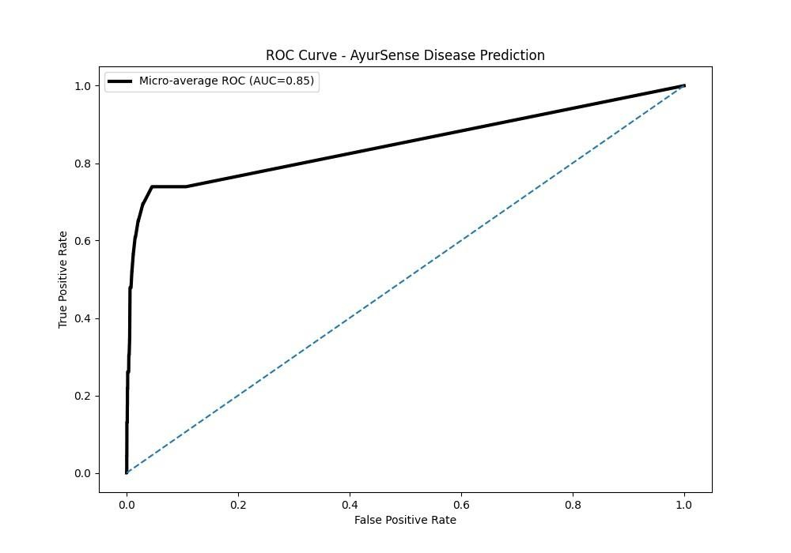
Figure 4.1: Receiver Operating Characteristic (ROC) curve

The performance of the classification system can be represented graphically through the ROC curve. Higher accuracy is represented by a curve that approaches more closely towards the upper-left quadrant. From the results obtained, it can be seen that the AYURSENSE system demonstrates reliable recommendation generation and effective classification capabilities.

4.6 Result Analysis
The results generated by the AYURSENSE system were analyzed to evaluate their accuracy and effectiveness. It was observed that the Dosha detection mechanism produces consistent results based on user input.
The recommendations provided by the system are relevant and aligned with Ayurvedic principles. The system successfully adapts to different user inputs and generates personalized outputs, making it more effective than static systems.
The analysis also shows that all modules are well-integrated and there are no major issues in data processing or output generation. Overall, the system meets the expected performance standards.

4.7 Limitations Identified During Testing
During the testing phase, certain limitations of the system were identified. These limitations highlight areas where improvements can be made in the future.
Although the system performs well, it relies on predefined datasets and simple logic, which may limit its ability to handle complex scenarios.
The major limitations include:
- Dependence on predefined dataset
- Limited number of quiz questions
- Absence of advanced machine learning techniques
- Generalized recommendations in some cases
These limitations provide opportunities for future enhancements.

4.8 Improvements After Testing
Based on the testing results, several improvements were made to enhance the system’s performance and usability. These improvements were necessary to ensure that the system provides accurate and reliable results.
The development process involved continuous testing and debugging, which helped in refining the system and improving its overall quality.
The improvements include:
- Enhancement of Dosha calculation logic
- Better structuring of dataset
- Improved user interface design
- Efficient handling of user inputs

These improvements ensure that the system delivers a better user experience.

4.9 Conclusion
Testing and evaluation played a significant role in ensuring the success of the AYURSENSE system. Through various testing methods, the system was thoroughly evaluated and improved.
The results show that the system is reliable, efficient, and capable of providing personalized Ayurvedic recommendations. Proper testing ensured that all modules function correctly and the system meets the desired objectives.
Overall, the testing phase contributed to improving system quality and ensuring a smooth and effective user experience
CHAPTER 5

TASK ANALYSIS AND SCHEDULE OF ACTIVITIES

5.1 Introduction
Task analysis and scheduling are crucial elements of project development since they facilitate workflow organization and guarantee that all tasks are completed on time. The process involved proper job analysis which helped to break down the development process into smaller parts that could easily be managed. Proper job analysis helped in making it easier to understand the complexity of the entire project and ensure that each phase was accomplished successfully.
It was essential because it ensured that each activity was completed within the stipulated time. It is important because it helps in ensuring that the project moves on track without any delay. Proper task analysis combined with proper scheduling makes the entire process of developing the system more systematic.
This chapter covers the identification and execution of tasks involved in the development of the AYURSENSE system.

5.2 Task Identification
Task identification involves recognizing all the activities required to complete the project. In the AYURSENSE system, the development process was divided into several stages, each consisting of multiple tasks.
Initially, the project requirements were analyzed to understand the objectives and expected outcomes. Based on this analysis, tasks related to system design, development, testing, and documentation were identified. Each task was clearly defined to ensure that it contributes to the overall goal of the project.
The major tasks identified in the project include:
- Requirement analysis and understanding system objectives
- Designing system architecture and workflow
Developing frontend interface
- Implementing backend logic
- Creating and managing datasets
- Integrating modules
- Testing and debugging
- Preparing documentation and report
Identifying these tasks at an early stage helped in planning the project effectively.

5.3 Task Decomposition
Task decomposition involves breaking down larger tasks into smaller and more manageable sub-tasks. This approach simplifies the development process and ensures that each component of the system is handled properly.
For example, frontend development was divided into tasks such as designing the homepage, creating the quiz interface, and developing the result page. Similarly, backend development included tasks like implementing Dosha calculation logic, managing datasets, and handling user requests.
By dividing tasks into smaller units, it becomes easier to assign responsibilities, monitor progress, and identify potential issues.
The decomposition of tasks includes:
- Breaking down major tasks into sub-tasks
- Assigning specific objectives to each sub-task
- Defining input and output for each activity
- Ensuring proper sequencing of tasks
This structured approach improves efficiency and reduces complexity.

5.4 Activity Scheduling
Activity scheduling entails giving each task a time limit and arranging them logically. This ensures that all activities are carried out within the project’s time frame and facilitates good time management.
Activities involved in carrying out the AYURSENCE project were done progressively where the second stage entailed design and development while the initial stage focused on research and requirements analysis. After developing the project, testing and evaluation took place followed by documentation.
The scheduling process ensures that activities are carried out sequentially and in accordance with the order of activities. This helps in identifying critical activities that require more attention.
The activity schedule can be summarized as:
- Phase 1: Requirement analysis and planning
- Phase 2: System design and architecture
- Phase 3: Frontend and backend development
- Phase 4: Testing and debugging
- Phase 5: Documentation and final submission
Proper scheduling ensures smooth execution of the project.

5.5 Gantt Chart Representation
A Gantt chart is a visual representation of the project schedule, showing the timeline of tasks and their duration. It helps in understanding how tasks overlap and how the project progresses over time.
In the AYURSENSE project, the Gantt chart was used to plan and monitor the development process. It provided a clear view of task durations and helped in tracking progress.
Although the chart itself is graphical, its key features include:
Representation of tasks along a timeline
- Indication of start and end dates
- Visualization of task dependencies
- Tracking of project progress
Using a Gantt chart improves project planning and ensures timely completion of tasks.

5.6 Resource Allocation
Resource allocation involves assigning available resources such as time, tools, and manpower to different tasks. Efficient resource allocation ensures that all tasks are completed without unnecessary delays.
In this project, resources included development tools, hardware systems, and the effort of the developer. Since the project uses open-source technologies, resource requirements were minimal.
Proper allocation of resources ensures that each task receives the necessary support and is completed efficiently.
The resources used include:
- Development tools (HTML, CSS, JavaScript, Flask)
- Hardware resources (computer system)
- Time and effort of developer
Efficient resource utilization contributed to the success of the project.

5.7 Time Management
Time management plays a crucial role in completing the project within the given deadline. It involves planning, organizing, and controlling the time spent on different tasks.
In the AYURSENSE project, time was managed by setting deadlines for each phase and monitoring progress regularly. Tasks were prioritized based on their importance and complexity.
Proper time management helped in avoiding delays and ensured that the project was completed on schedule.
The key aspects of time management include:
- Setting deadlines for tasks
- Prioritizing important activities
- Monitoring progress regularly
- Adjusting schedule when required

5.8 Risk Management
Risk management involves identifying potential risks and preparing strategies to handle them. During the development of AYURSENSE, several risks were identified and addressed.
These risks included technical challenges, data management issues, and time constraints. By identifying these risks early, appropriate measures were taken to minimize their impact.
The major risks include:
- Errors in backend logic
- Data inconsistency in dataset
- Integration issues between modules
- Delay in project completion
Proper planning and testing helped in managing these risks effectively.

5.9 Conclusion
Task analysis and scheduling played a vital role in the successful development of the AYURSENSE system. By breaking down the project into manageable tasks and organizing them effectively, the development process became more structured and efficient.
Proper scheduling ensured that all tasks were completed within the given timeline, while resource allocation and time management contributed to smooth execution. Overall, this structured approach helped in achieving the project objectives successfully.
CHAPTER 6

PROJECT MANAGEMENT

6.1 Introduction
Because it guarantees that the project is finished within the specified scope, time, and resources, project management is an essential component of software development. It involves planning, executing, controlling and coordinating all activities needed in achieving the objectives of the project. Effective project management played a critical role in the development and successful completion of the AYURSENSE project.
The development of the project involved the execution of several tasks that needed to be handled using a systematic approach in order to avoid inefficiencies. These included designing, developing, testing and documenting. Coordination of these activities would not have been possible without proper project management.
The issues covered under project management discussed in this chapter include planning, scheduling, risk management, and effective use of resources for the success of the AYURSENSE.

6.2 Project Planning
The first and most crucial stage of project management is project planning. It entails establishing the project's goals, specifying its tasks, and figuring out the resources needed to finish it.
Planning for the AYURSENSE project involved evaluating the system's scope and examining the needs. Creating an intelligent Ayurvedic suggestion system that offers individualized health remedies was the primary objective.
Defining system functionalities, choosing suitable technology, and developing a development roadmap were all part of the planning phase. This made guaranteed that every action was in line with the project's goals.
The following are essential components of project planning:
- Outlining the goals and parameters of the project
- Determining assignments and activities
- Choosing tools and technology
- Calculating resources and time
The groundwork for a project's successful completion was established by careful preparation.

6.3 Project Scheduling
Project scheduling involves organizing tasks in a logical sequence and assigning time frames to each activity. It helps in tracking progress and ensuring that the project is completed within the specified deadline.
In this project, scheduling was done by dividing the development process into different phases such as requirement analysis, design, development, testing, and documentation.
Each phase was assigned a specific duration based on its complexity.
The schedule was followed systematically, ensuring that tasks were completed on time. Regular monitoring of progress helped in identifying delays and taking corrective actions.
The main aspects of project scheduling include:
- Dividing project into phases
- Assigning time duration to each phase
- Monitoring progress regularly
- Adjusting schedule when required
This structured approach ensured timely completion of the project.

6.4 Resource Management
Effective use of available resources, including time, equipment, and labor, is a key component of resource management. Because there were few resources available for the AYURSENSE project, it was critical to make efficient use of them.
In order to lower development costs, the project made use of open-source technologies like HTML, CSS, JavaScript, and Flask. The system was accessible and simple to construct due to the low hardware requirements.
Effective time and effort management was also essential to the project's successful completion. Based on the complexity of each assignment, the proper amount of time was allotted.
The following resources are employed in the project:

- Technologies and techniques for development
- Computer system hardware resources
- The developer's time and work
Project execution went smoothly thanks to effective resource management.

6.5 Risk Management
Risk management is a crucial component of project management since it aids in anticipating issues and developing solutions. A variety of risks were identified and resolved in the process of developing AYURSENSE.
Technical risks included faults in back-end logic and inefficiencies in data management. Risks in terms of time and module integration also existed. The identification of these risks made it possible to implement appropriate strategies to address them.
Below is a list of the major risks associated with this project:
- Logic errors in computing Dosha
- Inconsistent data in the dataset
- Bad integration between front end and back end
- Time constraints during development

The risks have been managed through proper testing and debugging to ensure the stability of the system.

6.6 Team Management
Team management involves coordinating the efforts of team members to achieve project objectives. Although the AYURSENSE project may have been developed individually or in a small team, effective coordination was still necessary.
Proper communication and task distribution ensured that all activities were completed efficiently. Each member focused on specific tasks such as frontend development, backend implementation, or data management.
The key aspects of team management include:
- Clear communication among team members
- Proper distribution of tasks
- Coordination and collaboration
- Monitoring individual contributions
Effective team management contributed to the smooth development of the system.

6.7 Quality Management
Quality management ensures that the final product meets the required standards and performs as expected. In the AYURSENSE system, quality was maintained through continuous testing and improvement.
The system was tested at different stages of development to identify and fix errors.
Feedback from users was also considered to improve usability and performance.
Quality management focuses on:
- Ensuring accuracy of results
- Maintaining system reliability
- Improving user experience
- Continuous testing and debugging
This approach ensured that the system delivers high-quality performance.

6.8 Documentation Management
Documentation is an essential part of project development, as it provides detailed information about the system. It helps in understanding the design, implementation, and functionality of the project.
In the AYURSENSE project, documentation was prepared alongside development. It includes details about system architecture, modules, testing, and results.
Proper documentation ensures that the project can be easily understood and maintained in the future.
The documentation includes:
- Project report
- System design details
- Module descriptions
- Testing and evaluation results

6.9 Conclusion
Project management played a vital role in the successful development of the AYURSENSE system. Through proper planning, scheduling, and resource management, the project was completed efficiently and within the given timeline.
Risk management and quality control ensured that the system is reliable and performs as expected. Overall, effective project management contributed to achieving the project objectives and delivering a functional and user-friendly system.

CHAPTER 7

SYSTEM DESIGN AND ARCHITECTURE

7.1 Introduction
System design and architecture play a crucial role in defining how a software system is structured and how its components interact with each other. It provides a blueprint for the development process and ensures that the system is scalable, maintainable, and efficient.
In the AYURSENSE system, the design is focused on creating a modular and layered architecture that integrates frontend, backend, and data components seamlessly. The system is designed to handle user input efficiently, process data accurately, and generate personalized recommendations in real time.
This chapter explains the overall architecture, design principles, data flow, and technical structure of the system. It highlights how different components are organized and how they collaborate to achieve the desired functionality.

7.2 System Architecture Overview
The AYURSENSE system follows a client-server architecture, where the frontend acts as the client and the backend acts as the server. This architecture allows separation of concerns, making the system easier to develop, maintain, and scale.
The frontend is responsible for user interaction, while the backend handles data processing and logic execution. The data layer stores all necessary information required for generating recommendations.
The architecture is divided into three main layers:
- Presentation Layer (Frontend): Handles user interface and interaction
- Application Layer (Backend): Processes data and executes logic
- Data Layer: Stores datasets for recommendations
This layered approach ensures that each component performs its function independently while maintaining coordination with other components.

7.3 Design Principles
The design of the AYURSENSE system is based on several important principles that ensure efficiency, scalability, and usability. These principles guide the development process and help in creating a robust system.
The system is designed to be modular, meaning that each component is independent and can be modified without affecting other parts of the system. It also follows the principle of simplicity, ensuring that the system is easy to use and understand.
Key design principles include:
- Modularity for independent components
- Scalability for future enhancements
- Simplicity for better user experience
- Maintainability for easy updates
- Efficiency in data processing
These principles ensure that the system remains flexible and reliable.

7.4 Data Flow Architecture
The way data flows from input to output within a system is described by data flow architecture. Data flow in AYURSENSE starts with user interaction and concludes with the creation of tailored recommendations.
A user enters data via the quiz when interacting with the system. HTTP requests are used to send this data to the backend server. The backend extracts pertinent data from the dataset, computes the Dosha, and processes the data. After processing, the data is returned to the frontend and seen to the user.
Real-time processing is made possible by this flow, which guarantees effective communication between various components.
The data flow steps include:
- User enters data through quiz
- Data is sent to backend server
- Backend processes input and calculates Dosha
- Relevant data is retrieved from dataset
- Output is sent to frontend
- Results are displayed to user

7.5 Frontend Design Architecture
The frontend of the AYURSENSE system is designed to provide a smooth and interactive user experience. It is developed using HTML, CSS, JavaScript, Bootstrap which are widely used technologies for web development.
The frontend is structured into different pages, each serving a specific purpose. Navigation is designed to be simple and intuitive, allowing users to move easily between different sections of the website.
Responsive design techniques are used to ensure that the system works well on different devices, including desktops and mobile devices. JavaScript is used to handle user interactions and dynamically update content.
The frontend architecture includes:
- Structured web pages (Home, About, Quiz, Result, Blog)
- Responsive design for different devices
- Interactive elements using JavaScript
- User-friendly navigation system

7.6 Backend Design Architecture
The backend of the AYURSENSE system is implemented using Flask, which is a lightweight Python framework. It acts as the core processing unit of the system and handles all logical operations.
The backend receives user input from the frontend, processes it using predefined logic, and generates results. It also interacts with the dataset to retrieve relevant information.
Flask routes are used to manage communication between frontend and backend. Each route corresponds to a specific function, such as handling quiz submission or generating recommendations.
The backend architecture includes:
- Flask framework for server-side processing
- Routing system for handling requests
- Implementation of Dosha calculation logic
- Integration with dataset for recommendations

7.7 Database and Data Handling Design
The data handling design focuses on how information is stored, accessed, and processed within the system. AYURSENSE uses structured datasets instead of complex databases, making it lightweight and efficient.
Data is stored in formats such as JSON, which allows easy integration with Python and Flask. Each dataset is organized into categories such as quiz data, Dosha data, remedies, yoga exercises, and diet plans.
The system retrieves data dynamically based on user input, ensuring personalized output for each user. This design makes the system flexible and easy to update.
The data handling design includes:
- Use of structured datasets (JSON format)
- Categorization of data into different modules
- Dynamic retrieval of data
- Efficient data processing

7.8 System Workflow
The system workflow represents the complete sequence of operations performed by the system. It provides a clear understanding of how the system functions as a whole.
The workflow begins when the user accesses the website and proceeds to attempt the quiz. After submitting responses, the backend processes the data and generates recommendations. The results are then displayed on the screen.
The workflow steps include:
- User accesses the system
- User attempts quiz
- Data is sent to backend
- Backend processes input
- Dosha is calculated
- Recommendations are generated
- Results are displayed
This structured workflow ensures smooth execution of the system.

7.9 Advantages of the Architecture
The architecture of the AYURSENSE system provides several advantages that improve its performance and usability.
The system is modular and scalable, allowing easy addition of new features. The separation of frontend and backend ensures better organization and maintainability.

The advantages include:
- Modular and scalable design
- Efficient data processing
- Easy maintenance and updates
- Improved user experience
- Clear separation of components

7.10 Conclusion
The system design and architecture of AYURSENSE provide a strong foundation for its functionality and performance. The layered architecture ensures smooth interaction between components, while the modular design allows flexibility and scalability.
By combining frontend, backend, and data components effectively, the system is able to deliver personalized Ayurvedic recommendations efficiently. The design principles followed in this project ensure that the system remains reliable, maintainable, and userfriendly.

CHAPTER 8
SYSTEM INTERFACE AND OUTPUT SCREENSHOTS

8.1 Introduction
This chapter presents a detailed visual representation of the AYURSENSE system through various interface screenshots. It provides a clear understanding of how the system is designed from the user’s perspective and how different functionalities are implemented in a practical environment. The screenshots included in this chapter illustrate the complete workflow of the application, starting from the initial user interaction on the homepage to the final generation of personalized recommendations.
The main objective of this chapter is to demonstrate the usability, accessibility, and effectiveness of the system interface. A particular feature of the application, like registration of users, logging into the application, taking the quiz, and displaying the results, is explained in each section. It becomes easier for one to comprehend how the application interacts with its users and how smoothly navigation is done between different modules, using these pictures.
In this chapter, the various design principles that were used when creating the user interface are also emphasized. The application is very easy to use and access even by individuals who do not have any knowledge in computer programming.
It can be said that all in all, the pictures provide substantial evidence regarding the implementation of the system and help in understanding its working.

8.2 Home Page Interface
The home page is the first point of interaction for users. It introduces the AYURSENSE system and provides a brief overview of its purpose and features. The design is simple and attractive, ensuring a positive first impression.
The homepage includes navigation menus, a brief description of the system, and options to access different sections such as quiz, blogs, and login.

Figure 8.1: Home page Carousel Images

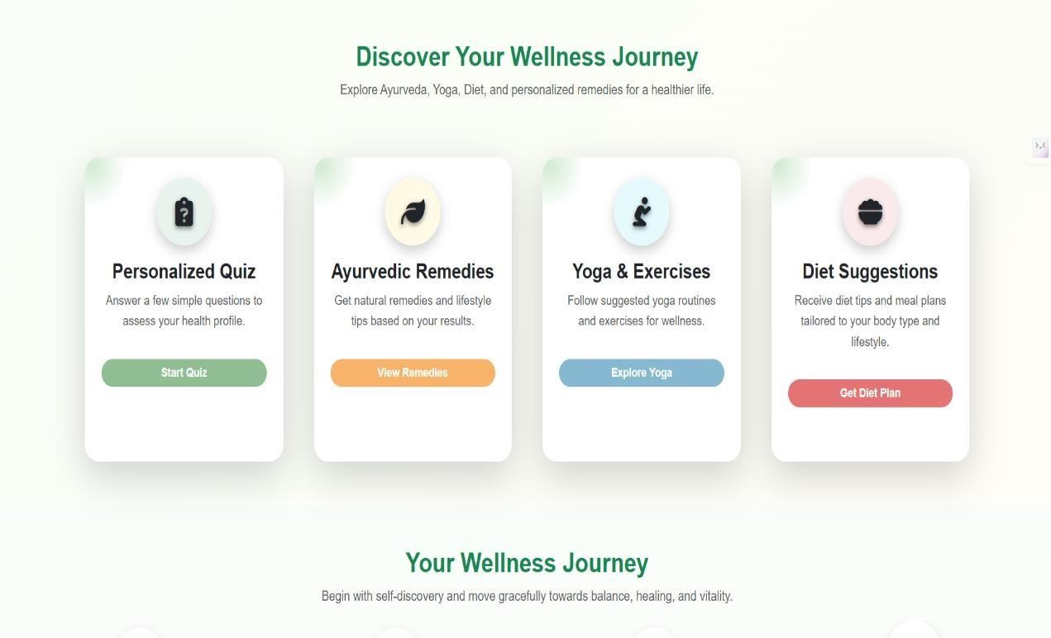
Figure 8.2: Home Page Interface (Discover your Wellness Journey)

8.3 About Section
The about section provides detailed information about the system and its objectives. It explains the concept of Ayurveda and how the AYURSENSE platform helps users understand their body constitution.
This section helps users gain trust in the system by explaining its purpose and functionality clearly.

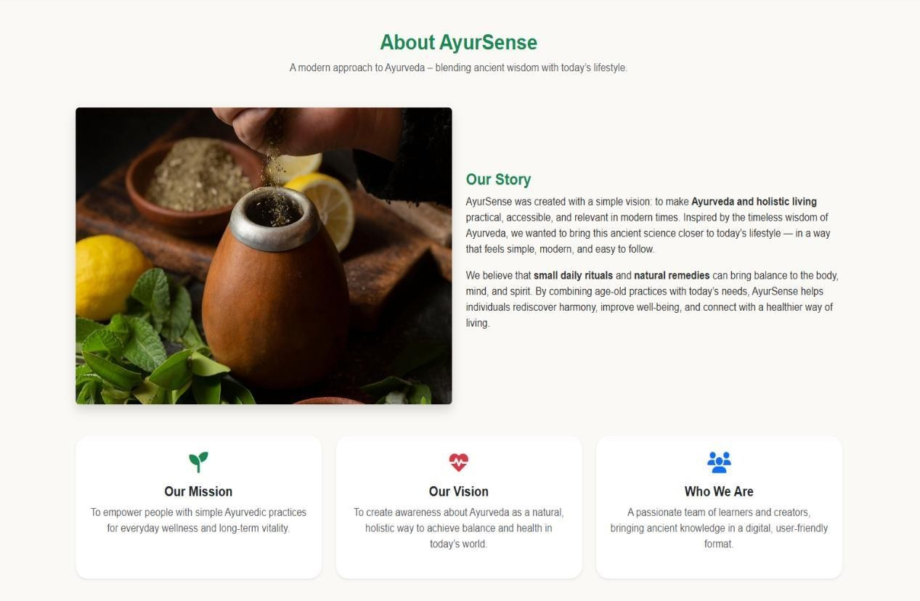
Figure 8.3: About Section

8.4 User Registration Page
The registration page allows new users to create an account in the system. It collects basic user details such as name, email, and password.
The interface is designed to be simple and secure, ensuring that users can easily register without any confusion.
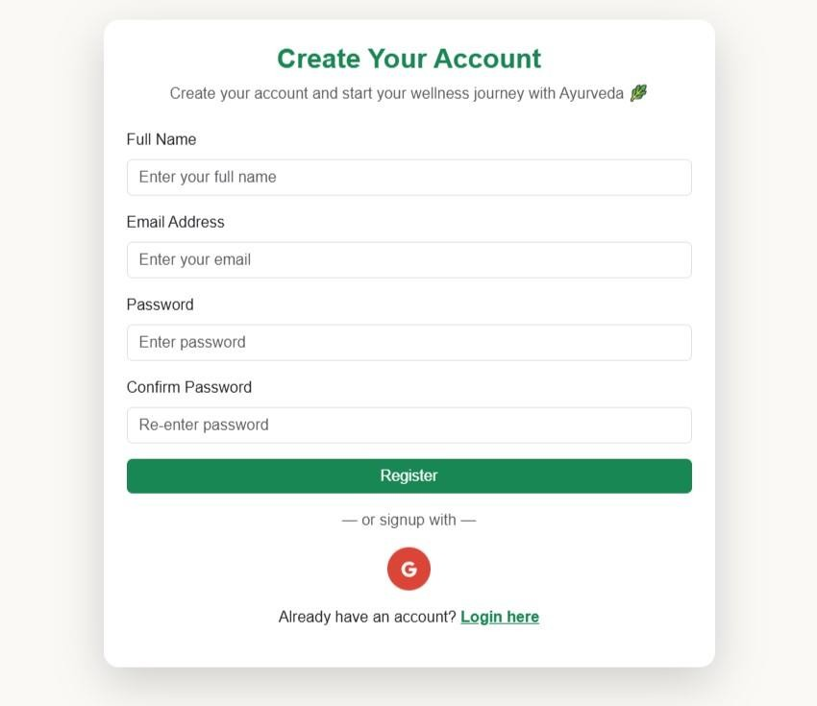
Figure 8.4: User Registration Page

8.5 User Login Page
The login page enables registered users to securely access their accounts and continue their interaction with the AYURSENSE system. This is necessary for user authentication and to ensure that only those who have been authorized can use the personalized features of the software.
There are usually prompts for users to key in their passwords and the registered email addresses. For purposes of validation and to avoid any kind of hacking, appropriate verification methods are used. Should the details inputted not be correct, the user is appropriately informed.
Additionally, the login process ensures that data unique to individual users is maintained, such as quiz results and tailored advice. After logging in, the site can be navigated effortlessly through different sections, where individuals can view their health tips.
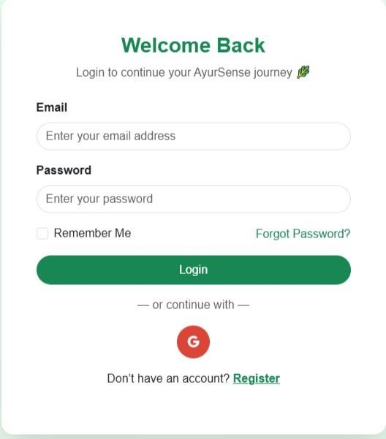
Figure 8.5: User Login Page

8.6 Personalized Quiz Interface
The personalized quiz interface is the core component of the AYURSENSE system, as it serves as the primary method for collecting user input. It consists of a set of thoughtfully crafted questions about daily routines, physical attributes, lifestyle, and health trends. Users may respond to these questions with ease and clarity because they are presented in an easy-to-understand format.
Users must choose the response option that most accurately characterizes their condition or behavior from the list of options provided for each question. A seamless user experience is guaranteed throughout the test thanks to the interface's interactive, aesthetically pleasing, and simple design. In order to keep users interested, a progress indicator that displays the number of questions completed is also added.
The user's responses are gathered and forwarded to the backend for examination. Using a predetermined logic, the system determines the dominance of Vata, Pitta, and Kapha Doshas based on these inputs. Because of this, taking the questionnaire is essential to producing precise and tailored recommendations.
Overall, the quiz interface is user-friendly, responsive, and plays a vital role in ensuring the effectiveness of the AYURSENSE system.

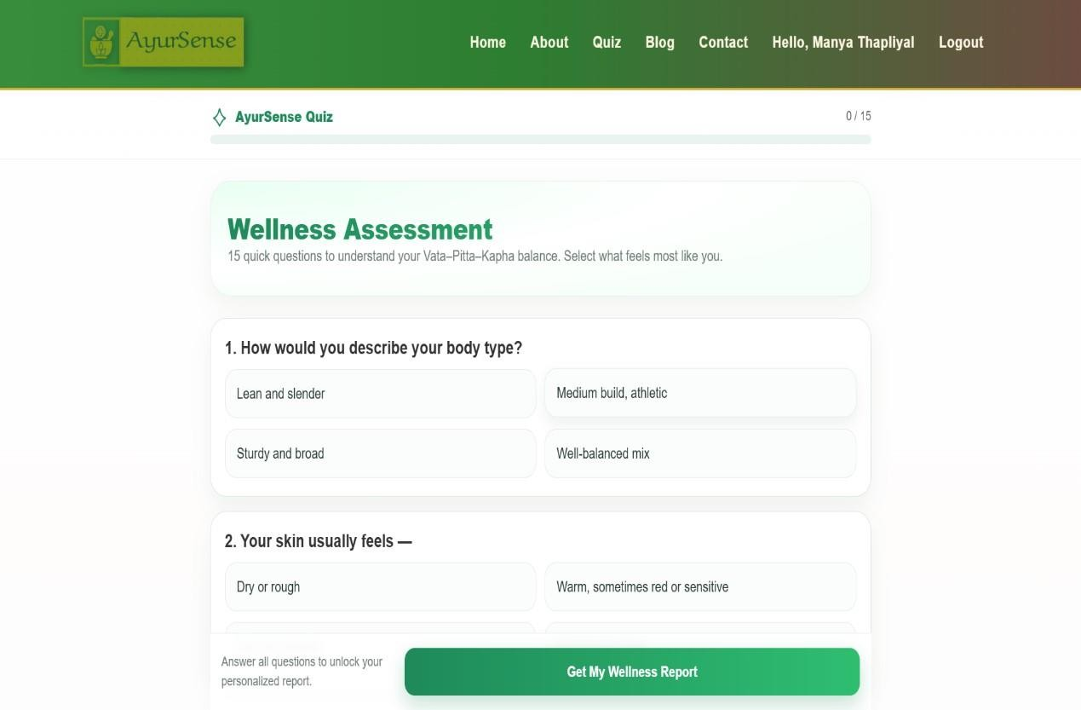

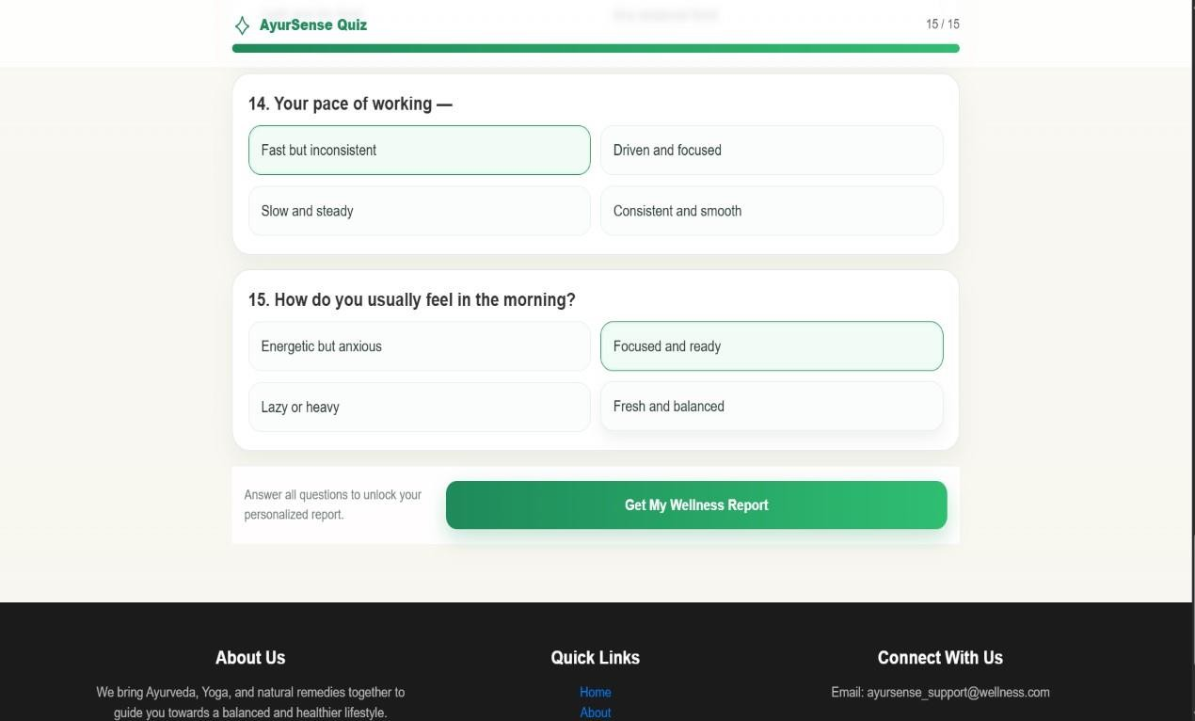

Figure 8.6: Personalized Quiz Interface

8.7 Dosha Result Page
After completing the quiz, the system processes the input and displays the dominant Dosha (Vata, Pitta, or Kapha). The result is shown in a clear and structured format.
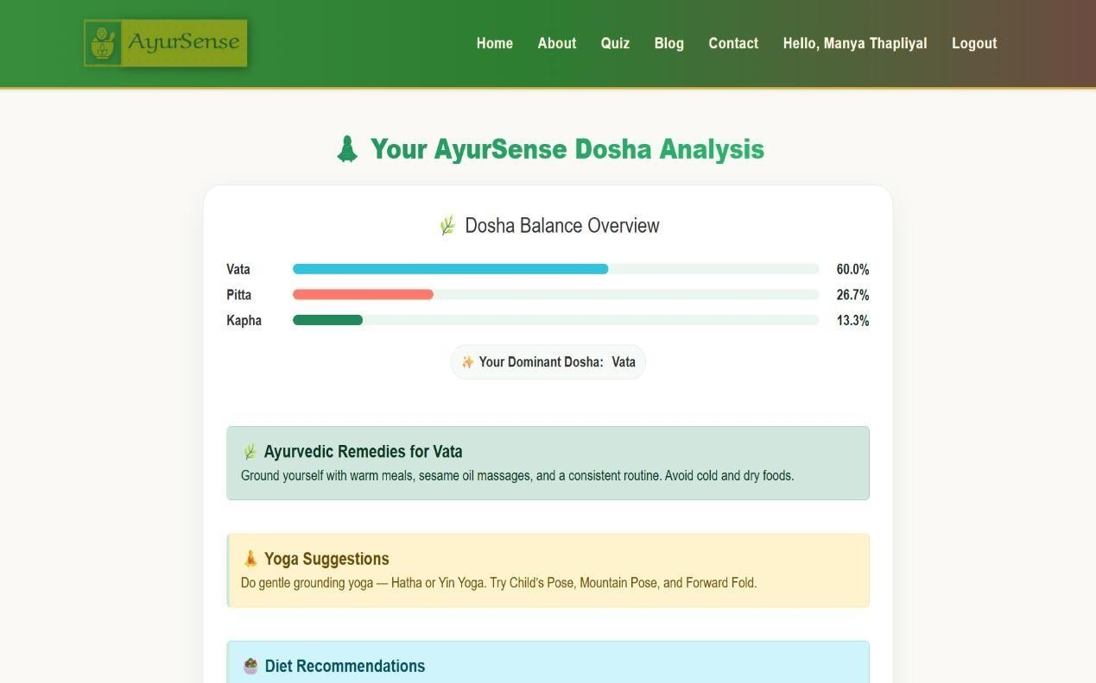

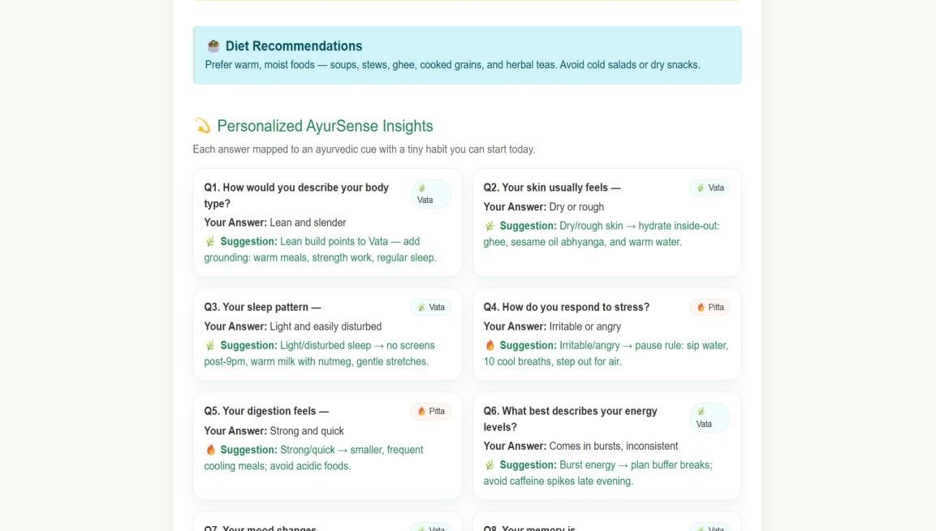

Figure 8.7: Dosha Result Page

8.8 Ayurvedic Remedies Section
This section provides personalized Ayurvedic remedies based on the user’s Dosha. It includes natural suggestions and lifestyle tips that help in maintaining balance in the body.
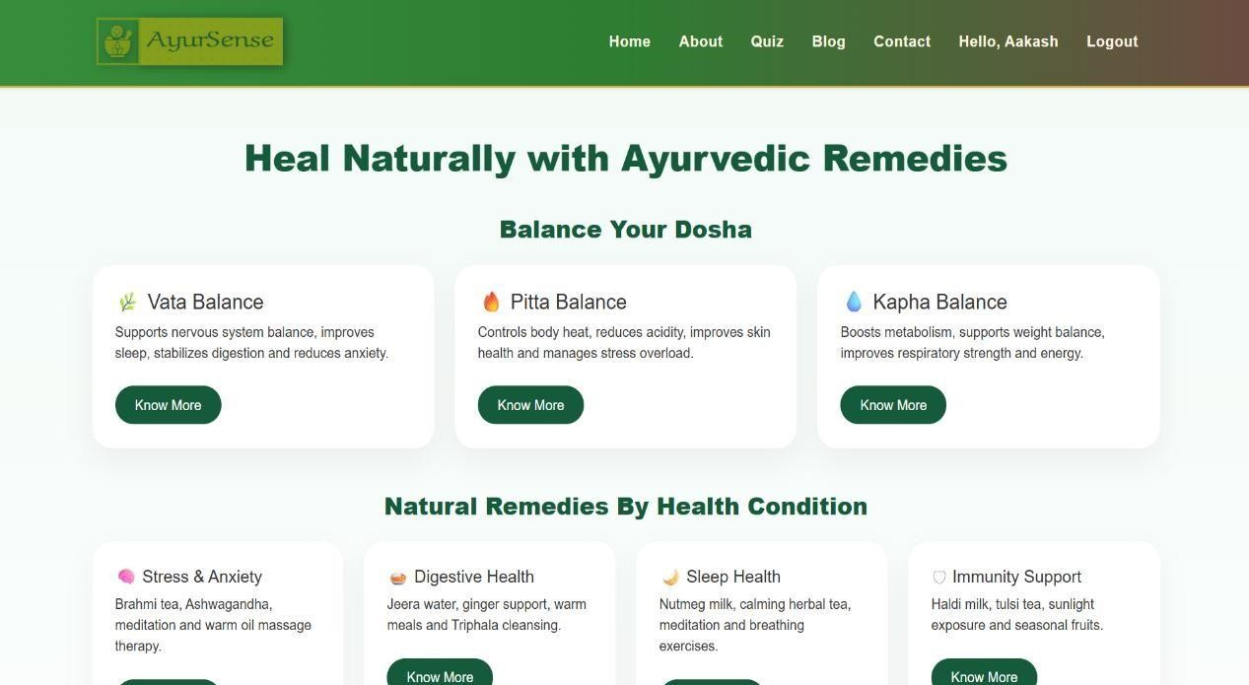

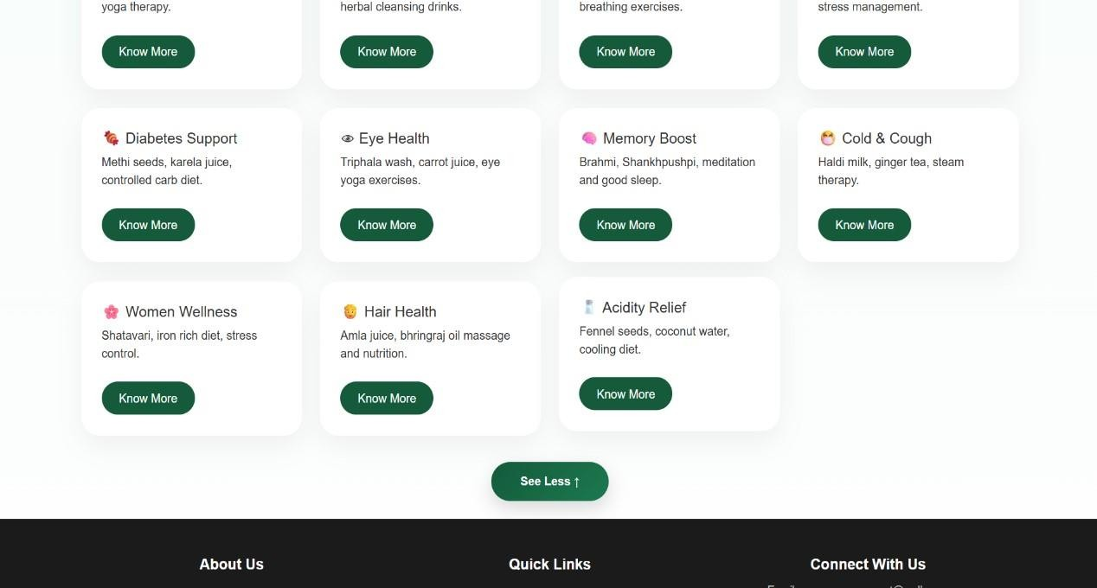
Figure 8.8: Ayurvedic Remedies Section

8.9 Yoga and Exercises Section
The yoga section suggests suitable exercises according to the user’s Dosha. These exercises help in improving physical and mental well-being.
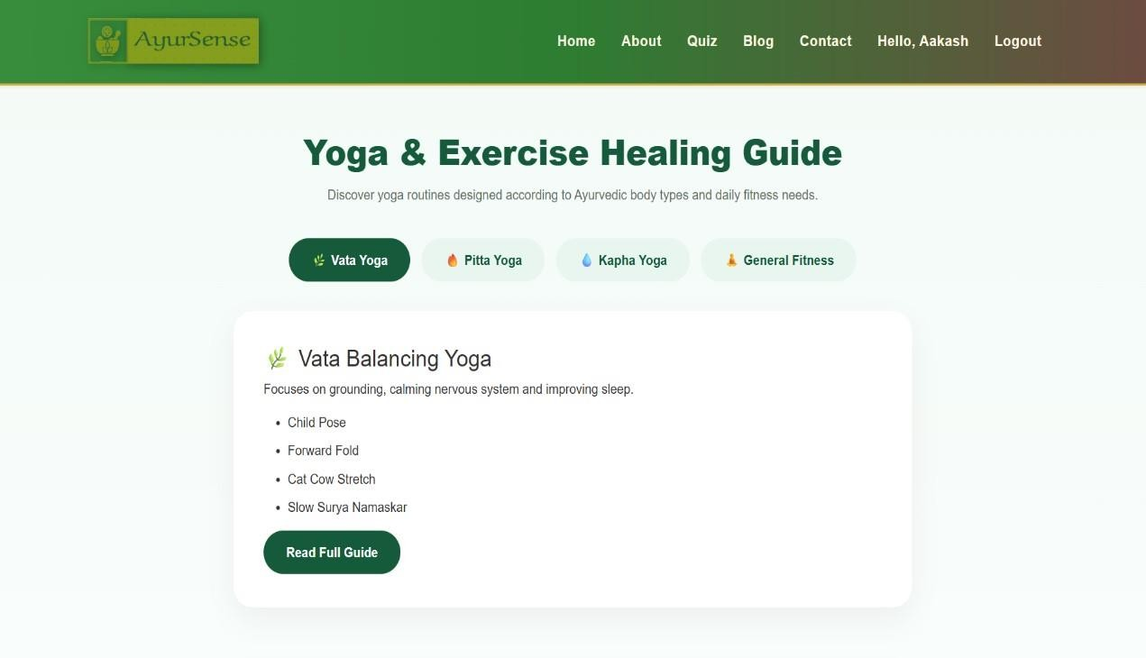

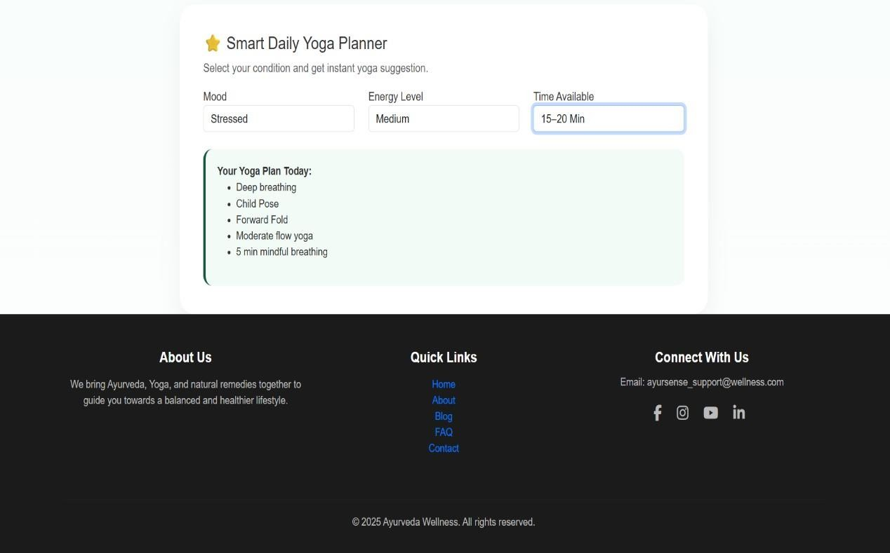
Figure 8.9: Yoga and Exercises Section

8.10 Diet Suggestions Section
This section provides personalized diet plans based on the user’s body constitution. It includes recommended food items and dietary habits.
The diet suggestions help users maintain a balanced and healthy lifestyle.
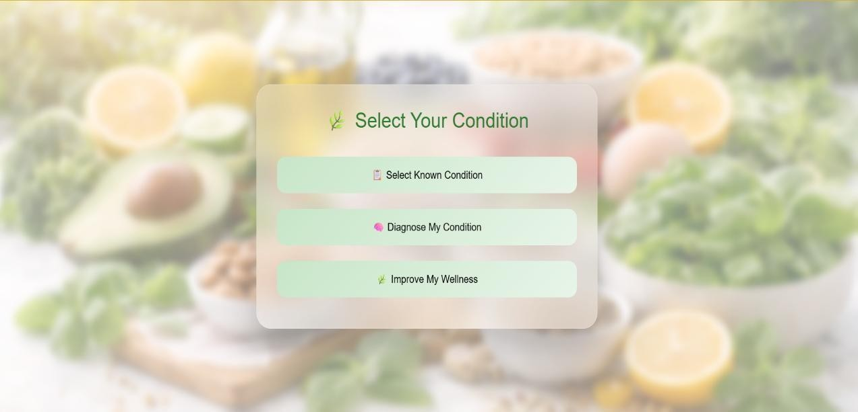

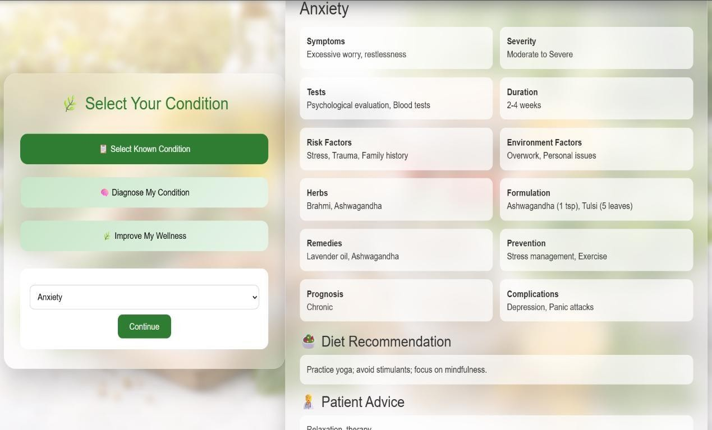
Figure 8.10: Diet Suggestions Section

8.11 Blog Section
The blog section contains informative articles related to Ayurveda and healthy living.
It helps users gain deeper knowledge about wellness practices.
This section enhances user engagement and awareness.
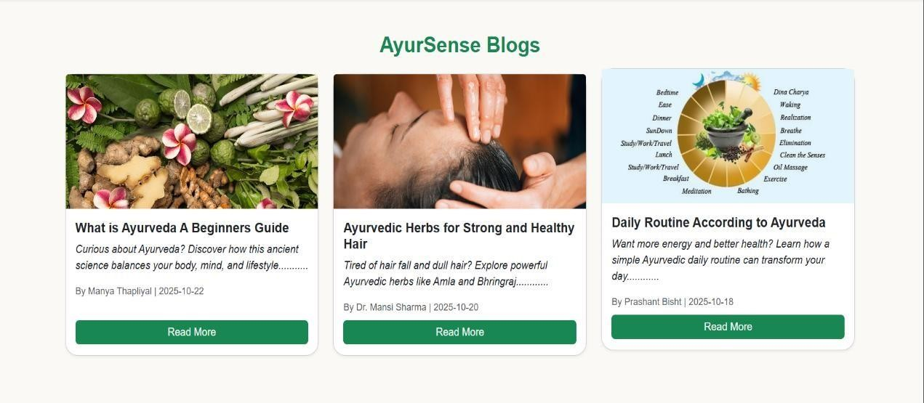
Figure 8.11: Blog Section

8.12-Footer Section
The footer section contains additional information such as contact details, navigation links, and other important resources.
It provides easy access to different parts of the website and improves overall usability.

Figure 8.12: Footer Section

8.13 FAQ Section
The FAQ (Frequently Asked Questions) section provides quick answers to common queries related to Ayurveda and the AYURSENSE platform. It helps users understand concepts like Dosha analysis, results timeline, and usability of the system.
The interface uses an interactive accordion design, allowing users to expand questions and view answers easily. This keeps the layout clean and user-friendly. It also includes options to explore more FAQs or contact support for further help.
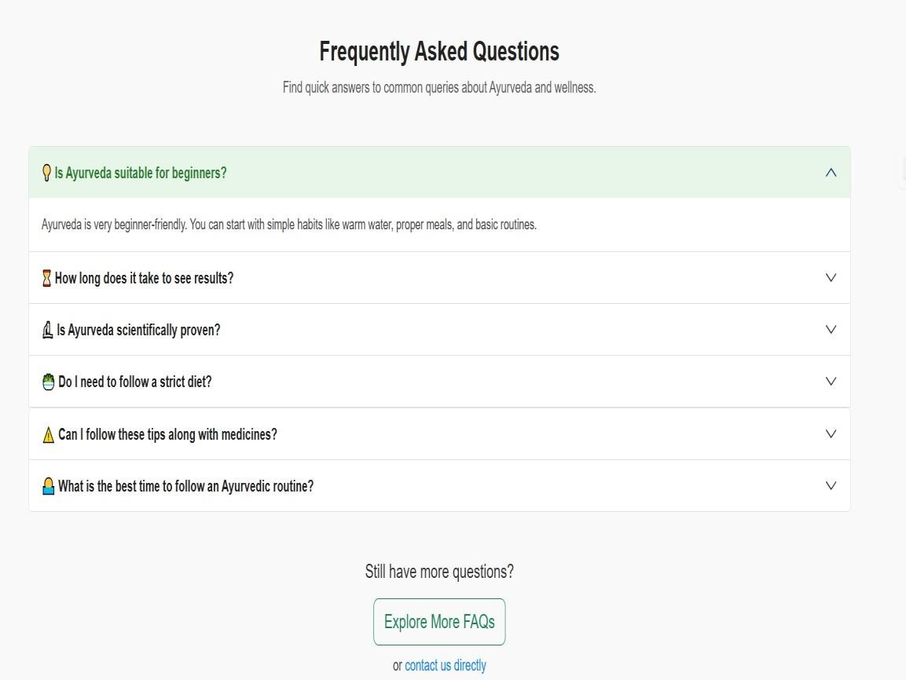

Figure 8.13: FAQ Section

8.14 Testimonials Section
The Testimonials section displays user feedback and experiences with the AYURSENSE platform. It highlights how users benefit from personalized recommendations and better understanding of Ayurveda.
The section presents reviews in a card-based layout, making it visually appealing and easy to read. It also includes a “Read More Testimonials” option to view additional feedback, helping build trust and credibility.



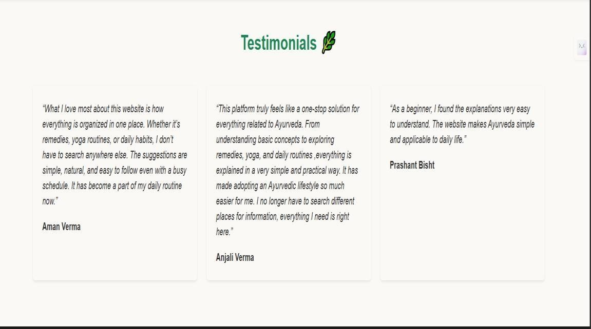

Figure 8.14: Testimonials Section

CHAPTER 9

RESULTS, CONCLUSION AND FUTURE SCOPE

9.1 Introduction
This chapter presents the final outcomes of the AYURSENSE system and evaluates its overall performance. It provides a comprehensive overview of the results obtained after implementation and testing, along with an analysis of system efficiency and accuracy. The chapter also highlights the advantages and limitations of the system and discusses potential improvements that can be made in the future.
The purpose of this chapter is to demonstrate how effectively the system achieves its objectives and how it contributes to improving user awareness about Ayurvedic health practices. It also reflects on the learning gained during the development process and the practical significance of the project.

9.2 Results of the System
The AYURSENSE system, a web-based tool that offers customized Ayurvedic advice, was successfully developed. All of the planned functions are carried out by the system, including Dosha identification, quiz-based evaluation, user interaction, and the creation of personalized outputs.
Users receive their dominant Dosha and pertinent recommendations, including yoga poses, food advice, and Ayurvedic treatments, after finishing the survey. Users may easily comprehend and follow the results because they are presented in an organized and easy-to-use style.
The system runs well and produces results instantly. The seamless integration of the frontend and backend guarantees accurate data processing and output display.
The main outcomes attained consist of:
- Accurate dosha (Pitta, Kapha, and Vata) identification
- The creation of tailored suggestions
- Yoga, nutrition, and remedy recommendations displayed
- Processing user input in real time
- Efficient system interaction and performance
These findings show that the system effectively achieves its design goals.

9.3 Analysis of Results
The efficacy and dependability of the AYURSENSE system's outcomes were assessed through analysis. Based on user replies, it was found that the system consistently generates outputs. The recommendations are in line with Ayurvedic principles, and the Dosha identification method operates with accuracy.
The system exhibits the capacity to adjust to various user inputs, guaranteeing that every user obtains distinct and customized recommendations. This dynamic behavior sets the system apart from static health platforms and increases its value.
The research also shows that there are no significant problems with data flow or processing, and the module integration is effective. The system is both efficient and user-friendly since it strikes a balance between functionality and simplicity.
Overall, the examination demonstrates that the system operates dependably and gives consumers useful outcomes.

9.4 Benefits of the System
The AYURSENSE system offers several benefits by combining traditional Ayurvedic knowledge with modern web technologies. It provides a platform where users can easily access personalized health guidance without requiring expert consultation.
The system promotes natural and holistic wellness by encouraging users to adopt healthy lifestyle practices. It also helps in increasing awareness about Ayurveda and its practical applications in daily life.
The major benefits include:
- Personalized health recommendations
- Easy-to-use and interactive interface
- Promotion of natural healing methods
- Quick and real-time result generation
- Accessible and cost-effective solution
These benefits make the system useful for a wide range of users.

9.5 Limitations of the System
Despite its effectiveness, the AYURSENSE system has certain limitations that need to be considered. These limitations are mainly related to the scope of the dataset and the simplicity of the implemented logic.
Since the system relies on predefined datasets, the recommendations are limited to the available data. The absence of advanced machine learning techniques restricts the system’s ability to learn and improve over time. Additionally, the number of quiz questions is limited, which may affect the depth of analysis.
The main limitations include:
- Dependence on predefined dataset
- Limited number of quiz questions
- Lack of advanced AI or machine learning models
- Recommendations may not cover all health conditions
These limitations highlight areas where the system can be improved in the future.

9.6 Future Scope
The AYURSENSE system has significant potential for future enhancement and expansion. By incorporating advanced technologies and expanding its capabilities, the system can become more powerful and widely applicable.
Future improvements may include the integration of machine learning algorithms to enhance the accuracy of recommendations. The dataset can be expanded to include more health conditions, remedies, and dietary options. The system can also be developed as a mobile application to increase accessibility.
Another important enhancement is the integration of user accounts, which would allow users to track their progress over time. Integration with wearable devices can also provide real-time health data, making the system more dynamic and responsive.
The future scope includes:
- Integration of machine learning techniques
- Expansion of dataset and knowledge base
- Development of mobile application
- Addition of user login and tracking features
- Integration with wearable health devices
These enhancements can significantly improve the system’s functionality and usability.

9.7 Practical Applications
The AYURSENSE system can be applied in various real-world scenarios to promote health and wellness. It can be used by individuals who want to maintain a healthy lifestyle using natural methods.
The system can also be used in educational institutions to create awareness about Ayurveda. Healthcare centers can use it as a supportive tool to provide basic guidance to patients.

The practical applications include:
- Personal health and wellness guidance
- Educational tool for learning Ayurveda
- Support system for healthcare awareness
- Lifestyle improvement platform

9.8 Overall Conclusion
The AYURSENSE project effectively illustrates how cutting-edge web technology may be combined with ancient Ayurvedic knowledge to produce an intelligent recommendation system. The primary aim of providing personalized health advice using user feedback has been achieved.
The research stresses the importance of addressing present-day health problems by blending conventional wisdom with modern technologies. The proposed tool provides an efficient means for users to understand their body type and opt for healthier lifestyles.
The system's reliability and effectiveness have been proven with proper design, implementation, and evaluation. Even with certain limitations, the system holds much potential for further development and improvement.
To conclude, AYURSENSE demonstrates practical application of technology in the realm of conventional medicine and serves as a helpful tool

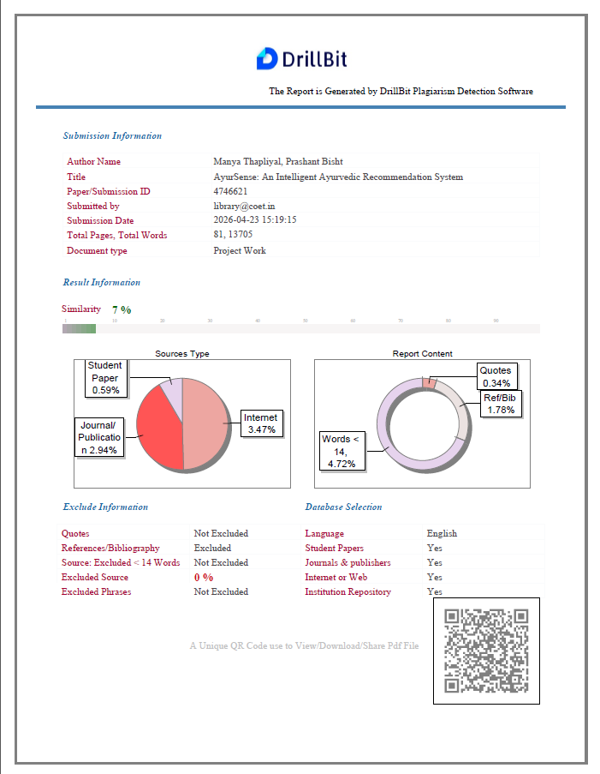

RESEARCH PAPER-1

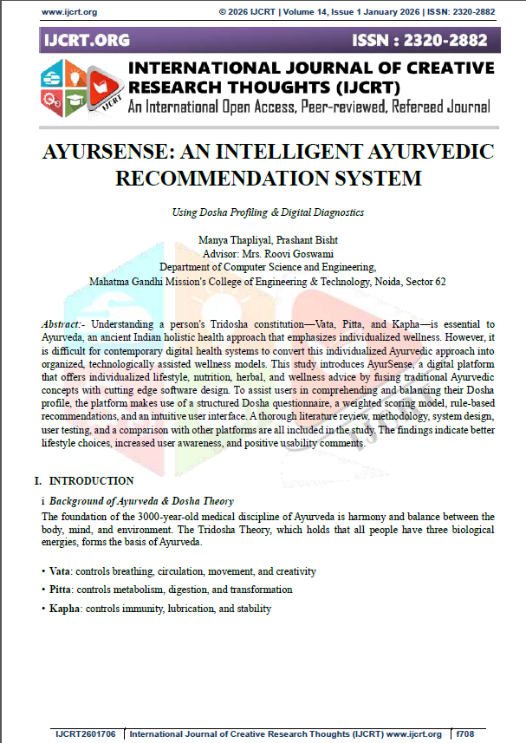
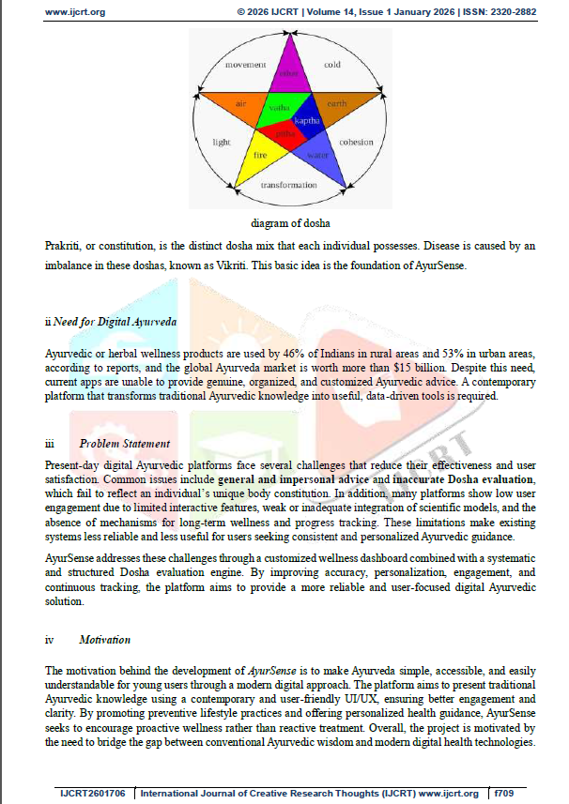

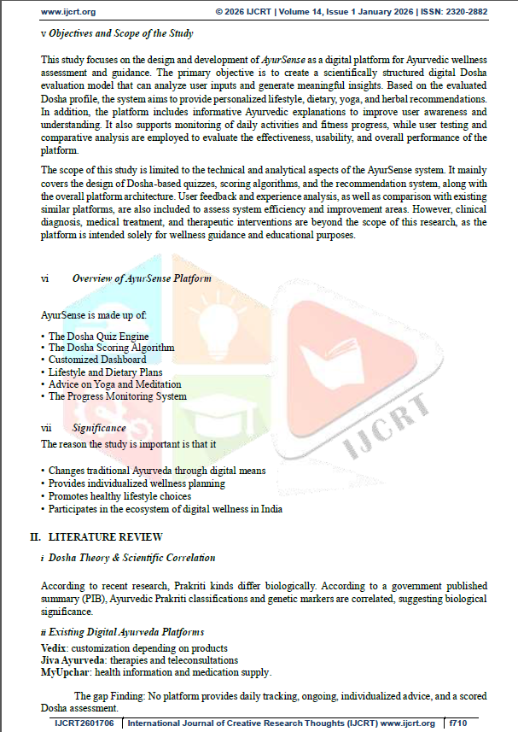

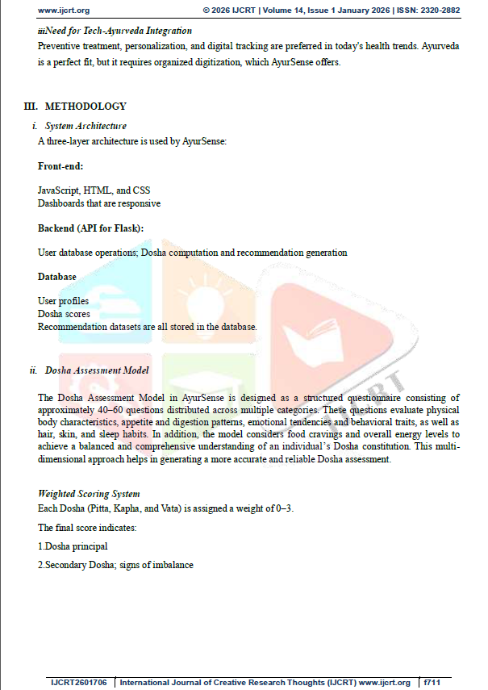

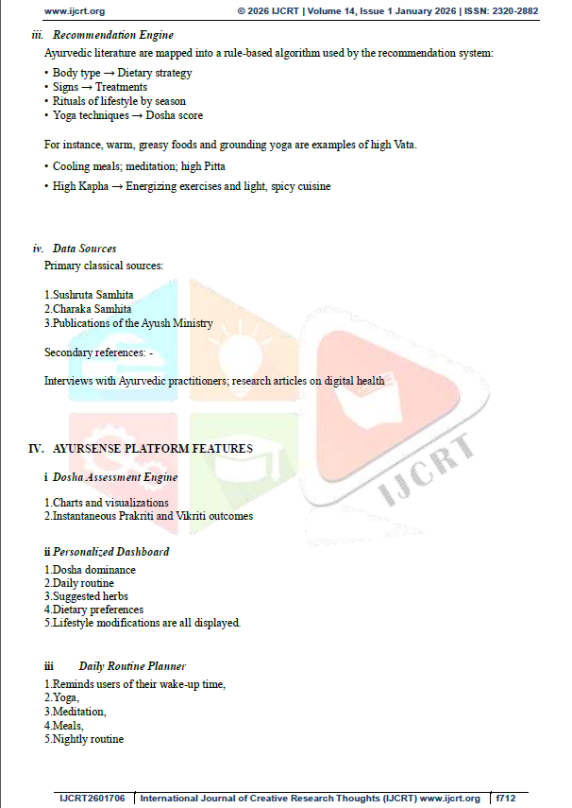

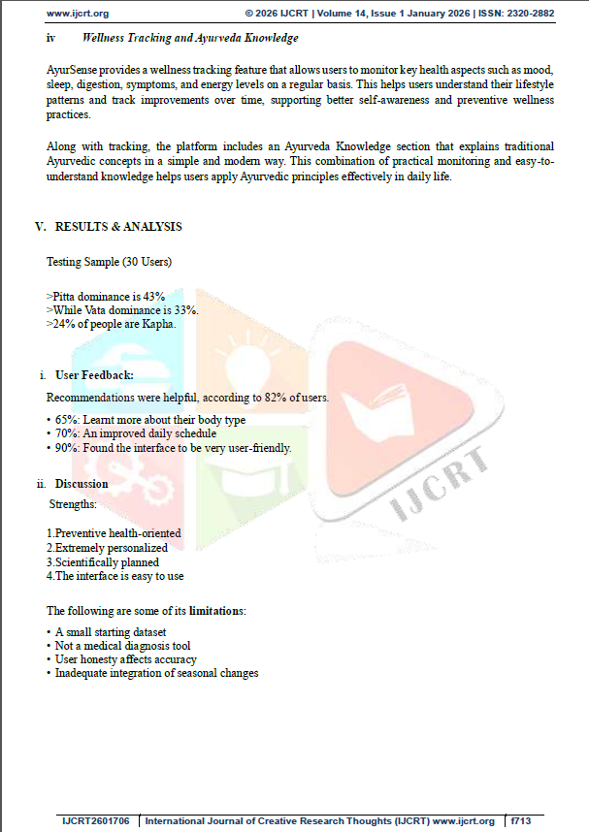

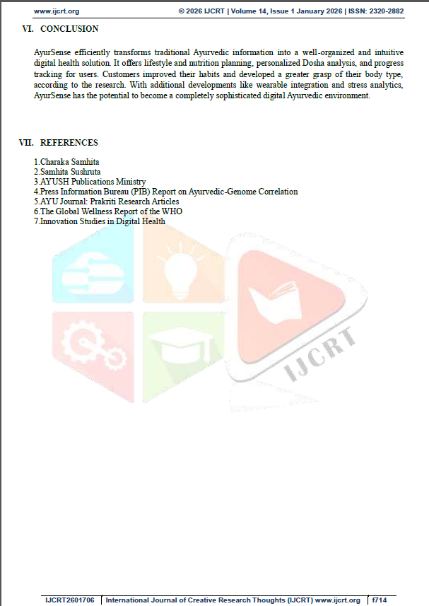

CERTIFICATE


RESEARCH PAPER-2

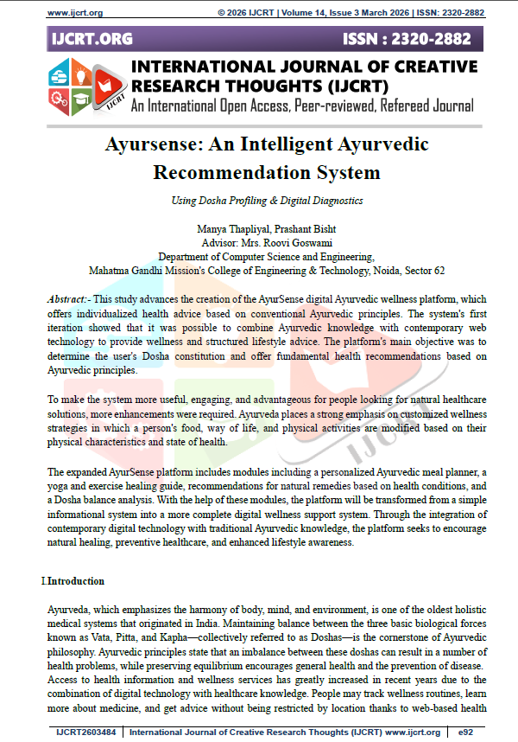

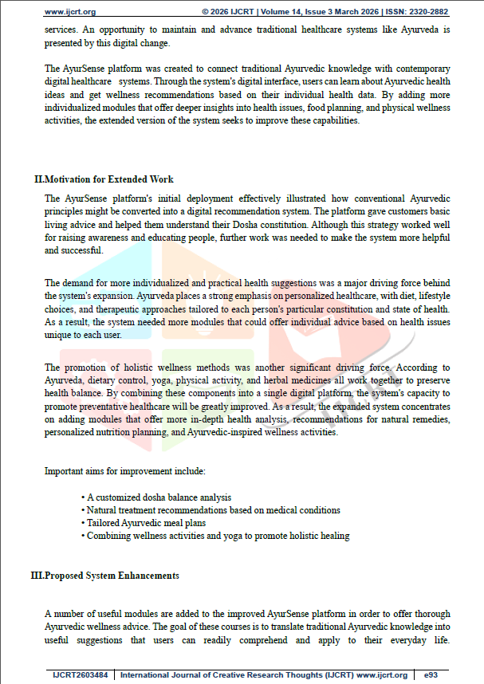

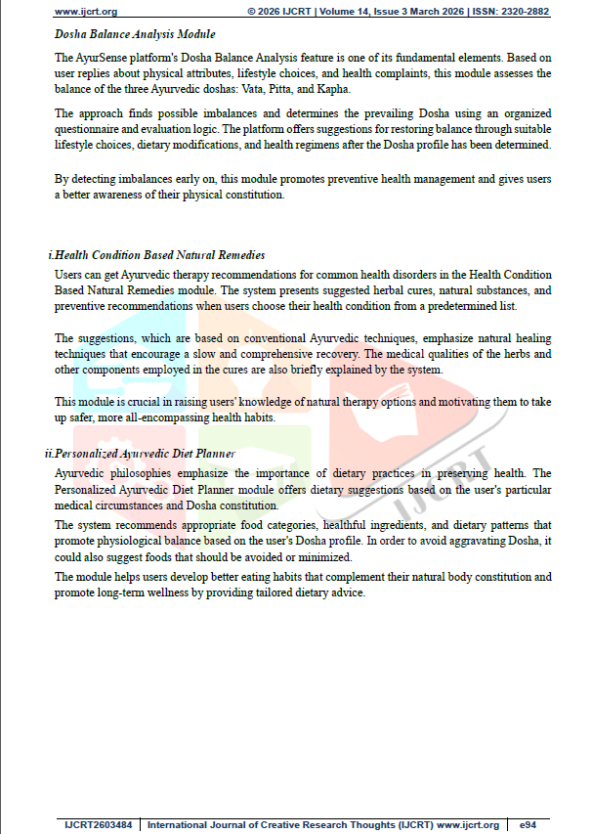

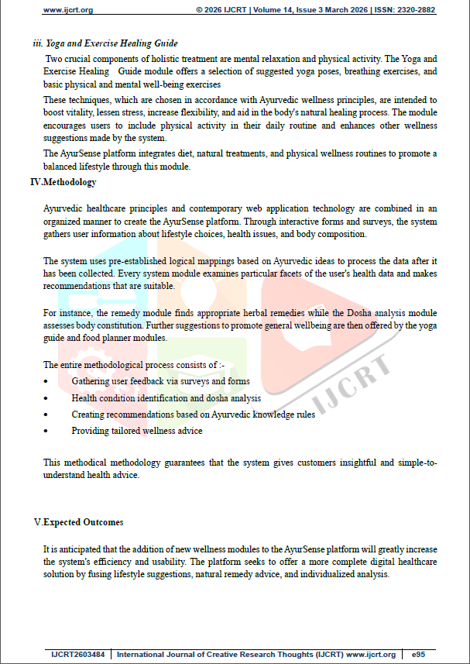

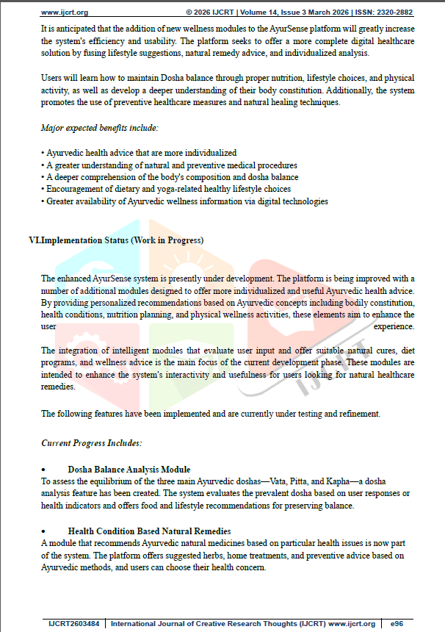

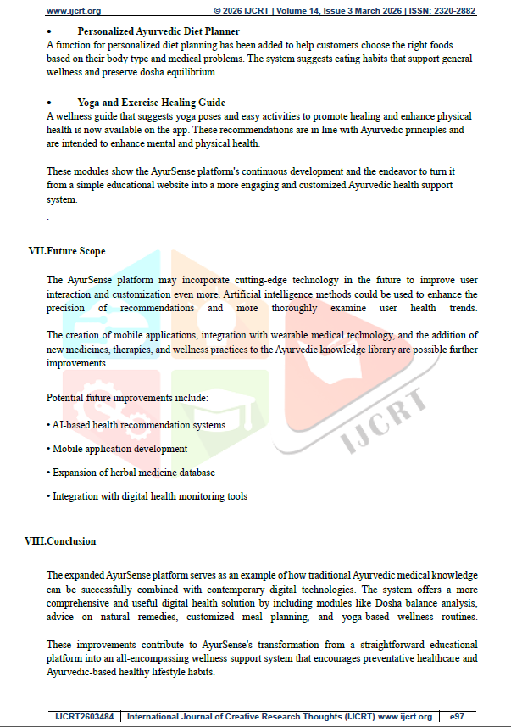



CERTIFICATE


REFERENCES

- Charaka Samhita, P. V. Sharma, Trans., Varanasi, India: Chaukhambha
Orientalia, 2008.

- Sushruta Samhita, K. R. Srikantha Murthy, Trans., Varanasi, India:
Chaukhambha Orientalia, 2012.

- World Health Organization, “Traditional, Complementary and Integrative Medicine,” [Online]. Available: https://www.who.int

- Ministry of AYUSH, “Ayurveda Overview,” [Online].
Available: https://www.ayush.gov.in

- M. Grinberg, Flask Web Development: Developing Web Applications with Python, 2nd ed. Sebastopol, CA, USA: O’Reilly Media, 2018.

- J. Duckett, HTML and CSS: Design and Build Websites. Hoboken, NJ, USA:
Wiley, 2011.

- D. Flanagan, JavaScript: The Definitive Guide, 7th ed. Sebastopol, CA, USA:
O’Reilly Media, 2020.

- Bootstrap, “Bootstrap Documentation,” [Online]. Available:
https://getbootstrap.com

- W3Schools, “Web Development Tutorials,” [Online]. Available:
https://www.w3schools.com

- V. Lad, Ayurveda: The Science of Self-Healing. Twin Lakes, WI, USA: Lotus Press, 2002.

- H. Sharma and H. M. Chandola, “Ayurveda in present scenario,” International Journal of Research in Ayurveda and Pharmacy, vol. 2, no. 3, pp. 1–5, 2011.

- National Institute of Ayurveda, Jaipur, “Research publications on Dosha and lifestyle practices,” [Online]. Available: http://nia.nic.in

- Flask Documentation, “Flask Official Docs,” [Online].
Available: https://flask.palletsprojects.com

- A. Géron, Hands-On Machine Learning with Scikit-Learn, Keras, and TensorFlow, 2nd ed. Sebastopol, CA, USA: O’Reilly Media, 2019.

- I. Goodfellow, Y. Bengio, and A. Courville, Deep Learning. Cambridge, MA, USA: MIT Press, 2016.

- T. Mitchell, Machine Learning. New York, NY, USA: McGraw-Hill, 1997.

- S. Russell and P. Norvig, Artificial Intelligence: A Modern Approach, 4th ed.
Upper Saddle River, NJ, USA: Pearson, 2021.

- P. D. Kaur and R. Kaur, “Application of artificial intelligence in healthcare,” International Journal of Computer Applications, vol. 179, no. 39, pp. 10–15, 2018.

- GitHub, “GitHub Documentation,” [Online]. Available: https://github.com

- MDN Web Docs, “Web Development Guide,” [Online]. Available:
https://developer.mozilla.org.

